Working document Otolith collection of target species in the IBTS

Summary

Introduction

The International Bottom Trawl Survey (IBTS) collects otoliths of target fish species to establish the age of individual fish to provide an age-based index which is used in the assessments. Only a small fraction of the catch is typically analyzed for age as this is a costly and time-consuming process. With the otoliths of this fraction of the catch an Age-Length-Key (ALK), e.g. the percentage of otoliths of a particular length of the fish were of age1, age2, etc, is constructed. This ALK is than used to transform the total numbers at length which is collect of the whole catch into numbers at age.

The ALK for the IBTS is not constructed for the whole survey area, instead multiple ALKs are constructed for smaller spatial units, the so called roundfish areas (RFA). These roundfish areas are based on historic stock structures of some of the target species. In line with that the current IBTS otolith sampling scheme is based on the RFA, while the stratification unit of the survey is a smaller unit, the ICES rectangle which is fished twice by two different countries (Fig 1). The current scheme dictates the collection of a specific number of otoliths per cm- or 0.5 cm-class by country by RFA. As the rectangles are distributed by country and not the RFA, multiple countries fish in the same RFA resulting in large numbers of otolith samples collected. Despite of that, it happens that otoliths are not collected from length classes (0.5 cm or cm) caught within a RFA. As a result gaps occur in the ALK, which are filled by borrowing from neighbouring areas.

Despite the guidelines in the manual, the sampling method varies between country and between species. Scotland and Norway adopted a station-specific sampling scheme ensuring to collected at least the numbers by RFA. The other countries tried to meet the required numbers by sampling from a selection of tows. Often the first tow in which the species is caught in a RFA is sampled intensively, while in the following tows it is tried to fill up the missing otoliths. Resulting in a skewed number of otoliths per tow. If known that the species and length classes are likely to be caught more in that RFA the intensity with which the first tow is sampled is reduced. For the pelagic species sprat, herring and mackerel the Netherlands sampled the otoliths by groups of 25, which is convenience with the way they further process the otoliths. This often results in a small number of tows within a RFA being sampled.

The current scheme combined with differences in sampling methods used reduces the flexibility in the survey. Exchanging rectangles between countries, when weather or mechanical issues affect the execution of the original program, might reduce or enhance the number of otoliths collected within a RFA. Proposals for altering the whole distribution of sampling stations, increasing the number of rectangles covert twice by a single country and reducing the number of countries fishing within a RFA. As well as the proposals to relax the fixed spatial distribution by country are complicated by differences in sampling method.

Furthermore, age at length has been observed to vary spatially and temporally (Aanes and Vølstad, 2015) and as shown in west of Ireland haddock that the consequences of this bias would have been a nearly twofold overestimate of the 2003 year class, and an underestimate of the spawning stock by 15% (Gerritsen et al., 2006). Since with the current routine of preparing one ALK for an entire RFA, variance within a RFA cannot be considered. Typically, the lengths and ages of fish sampled in clusters exhibit positive intra-cluster correlation, which can drastically reduce the effective sample sizes for estimating length- and age-compositions (e.g. Pennington and Vølstad, 1994; Aanes and Pennington, 2003). This pleas for an station-specific sampling scheme.

Aanes and Vølstad (2015) found no gain in precision from collecting 10 instead of only 1 otolith per 5-cm length class. While this result obviously depends on species and geographical area tested, it appears promising to conduct an analogous analysis for the IBTS, where the concept of the effective sample size would be used to calculate how many specimens are needed to be aged to maintain the same level of precision as with the original number sampled. There is strong evidence to suggest that the number of otoliths per length class sampled in the IBTS could be significantly reduced without any significant loss in precision of the overall estimates being recorded. This would be beneficial as processing the otoliths is costly and time-consuming, but also to reduce the number of experimental animals required.

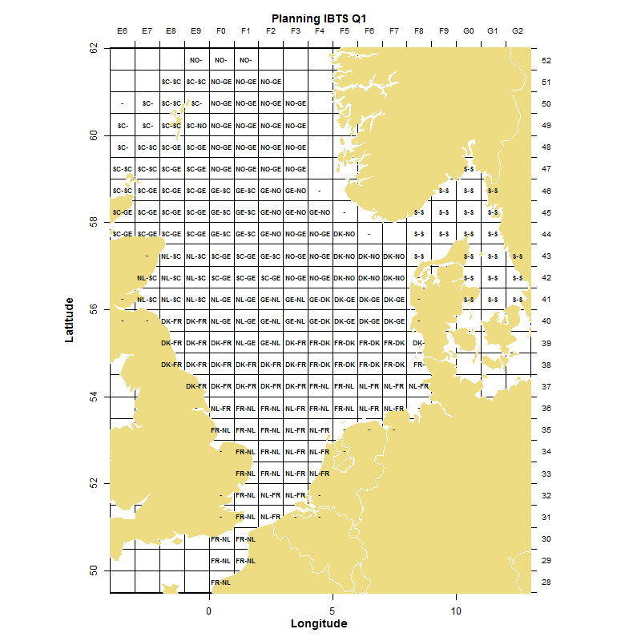

Fig 1: Spatial distribution of the ICES-rectangles in the IBTS Q1 over the participating countries. SC=Scotland, GE= Germany, NO= Norway, DK= Denmark, FR= France, NL= The Netherlands, S=Sweden.

A preliminary analysis had been conducted during the 2015 IBTSWG (ICES, 2015), which provided results supporting this proposal. A subset of the Q3 North Sea IBTS data from Scotland had been used, where the otolith collection was conducted using a ‘by station’ sampling scheme. Post-subsampling of fewer individuals allowed testing for the effect of the number of individuals aged per length group and per station. Results obtained during the preliminary study for the species whiting, haddock and Norway pout suggested that a reduced sampling scheme could be sufficient. In this, sampling per haul is prerequisite. Then, for some of the smallest size classes, otolith collection may be omitted altogether, and medium-sized fish, wider size classes (5 cm) can be appropriate, whereas for the largest individuals, narrower size classes (1 cm) would again be recommended.

Here, we have extended upon those preliminary analysis. We used the full set of samples of a single year and quarter and created a real population of the specific species based on this. From this population we bootstrapped the otoliths according to the original sampling scheme and in a by station-specific sampling scheme varying the number of otoliths taken from length classes. Using the current method of estimating the ALK and a by station modelled ALK the population was reconstructed to estimate the variance created by the different methods.

Method

IBTS Q1 and Q3 data of whiting and herring stored in the Datras database were used. The used data were the tow information (HH), the length measurements of fish (HL) and the ALK data product. Using this data a “real” population was established for each year. The ALK by RFA was combined with the length measurements by tow and every measured fish was given an Age. The “real” population existed of number by length and age for each tow. Because the ALK was created for each RFA, the real population has no local stock structure.

This “real” population was than sampled according to the manual, the sampling was done randomly from all fish in the RFA for that country. Each country fishing in a RFA collects up to a maximum of 8 otoliths per cm-class, or in case of herring 0.5 cm-class. This gives the maximum number of otoliths collected for the catches in that specific year, it is likely that in the field not all countries collect the maximum number for all length-classes. The sampling was bootstrapped without replacement 501 times. Then for each of the bootstraps the ALK by RFA was constructed and used to create the numbers at age.

The same bootstrapping was done, but then by tow from which a defined number of otoliths per length class was taken (table 1). These otoliths were than combined into an ALK by RFA to calculate the numbers at age similarly as done in the current situation. In the third method the otolith sampling was the same but than an ALK was modelled by tow using a multinominal model explaining Age by an interaction term of (longitude*latitude)*Length.

Following Aanes and Vølstad (1994) a goodness of fit statistic F was used to identify which of the methods produced the most accurate estimate of the age of the “real” population.

Where a is the proportion-at-age a of the estimated population, and Pa is the proportion-at-age a of the “real” population. F is zero for =P and increases with increasing difference between the estimated and “real” proportion-at-age.

Table 1: The methods used for sampling the “real” population, indication until what length 5cm classes are used and the number of otoliths collected by 5 cm class. Than showing from which length cm or 0.5 cm-classes are used and the number of otoliths collected by these length classes. The last column shows the number of otoliths the method results in in 2010.

|  |  |  |  |  |  |  |
| --- | --- | --- | --- | --- | --- | --- |
| **Species** | **Method** | **5cm** | **# Otoliths** | **1 cm** | **#Otoliths** | **Total otoliths 2010** |
| Whiting | Base |  |  | all | 8 | Q1 5003; Q3 4536 |
|  | 1 | <30 | 2 | >29 | 1 | Q1 2572; Q3 2766 |
|  | 2 | <10 | 1 | >9 | 1 | Q1 4037; Q3 3105 |
| **Species** | **Method** | **5cm** | **# Otoliths** | **0.5 cm** | **#Otoliths** | **Total otoliths 2010** |
| Herring | Base |  |  | all | 8 | Q1 4892; Q3 4450 |
|  | 1 | <25 | 2 | >25 | 1 | Q1 1741; Q3 1800 |

Results

In the appendix the results of the various methods for whiting and herring using the 2010, 2013 and 2015 ICES data are presented. For each method by year and quarter the estimated numbers at age and the numbers at age of the “real” population (red dot) are given in figure A. In the first glance the boxplots showing the variation created by the bootstraps follow the pattern in the red dots. In most cases in Q1 the highest number being age 1, and in Q3 the highest number being age 0. Figure b shows the estimated values divided by the “real” population, the red dot is thus 1. Here, the discrepancy between the estimations and the “real” population become visible. It is often clear that the red dot is not even within the boxplot, indicating that in those cases the majority of the estimations over or underestimate the “real” population. This is already the case the base method (the current situation) in which the largest number of otoliths is collected and is visible in all the other methods as well. The boxplots showing the discrepancies become bigger at the larger ages, while the difference in total numbers at age become smaller as the “real” population has less fish at these ages.

The median F statistic for whiting (table 2) gives a clear picture that the base method is better than the other methods. Only for Q1 2013 the model 1 creating the ALK in the current way is surprisingly slightly better. The modelled data is all cases worse than using the current method for the ALK. Comparing model 1 and model 2, where model 2 collects more otoliths indicates that a higher number of otoliths improves the estimations.

Table 2: The median F statistic for the various method used to estimate the numbers at age for whiting. The lower the values the closer the estimate is to the “real” population.

|  |  |  |  |  |  |  |
| --- | --- | --- | --- | --- | --- | --- |
|  |  |  | base | model1 | model1 | model2 |
|  |  |  | current | current | modelled | modelled |
| Whiting | Q1 | 2010 | 0.0055 | 0.0120 | 0.0225 | 0.0143 |
|  | Q1 | 2013 | 0.0150 | 0.0147 | 0.0335 | 0.0138 |
|  | Q1 | 2015 | 0.0074 | 0.0108 | 0.0181 |  |
|  | Q3 | 2010 | 0.0009 | 0.0027 | 0.0072 | 0.0030 |
|  | Q3 | 2013 | 0.0019 | 0.0023 | 0.0040 | 0.0030 |
|  | Q3 | 2015 | 0.0024 | 0.0037 | 0.0088 |  |

The median F statistic for herring shows a different picture than the values for whiting (table 3). For Q1 2015 and Q3 2013 model 1 with the current way of estimating the ALK preforms surprisingly better than the base model. This is a surprise as less otoliths are collected in this method. The model 1 with a modelled ALK performs best in Q1 2013 and performs better than model 1with the current modelling method in Q1 2010 and Q3 2015.

Table 3: The median F statistic for the various method used to estimate the numbers at age for herring. The lower the values the closer the estimate is to the “real” population.

|  |  |  |  |  |  |
| --- | --- | --- | --- | --- | --- |
|  |  |  | basis | model1 | model1 |
|  |  |  | old | old | modelled |
| her | Q1 | 2010 | 0.0055 | 0.0079 | 0.0059 |
|  | Q1 | 2013 | 0.0150 | 0.0363 | 0.0049 |
|  | Q1 | 2015 | 0.0074 | 0.0014 | 0.0076 |
|  | Q3 | 2010 | 0.0009 | 0.0085 | 0.0096 |
|  | Q3 | 2013 | 0.0019 | 0.0005 | 0.0019 |
|  | Q3 | 2015 | 0.0024 | 0.0116 | 0.0081 |

The differences in F statistic are clear but very variable. The absolute difference in proportion-at-age is small. An example is the Q3 2015 for whiting: here age 1 shows underestimation, while age 2 shows overestimation. The proportion-at–age 1 of the “real” population is 0.1244940 and for age 2 is 0.09532597. The range shown by the estimates for age 1 is 0.1044134-0.1282833, and for age 2 0.09436893-0.11694229. For age 5 for example the range is 0.005398927-0.008927476. This is the reason that the graphs of proportion-at-age as shown in the working document of last year did not show much difference.

Discussion

The current analyses provide a perturbing image of the current and the proposed otolith sampling methods. In all cases clear over and underestimation of the “real” population occurs, which in absolute numbers is larger in the smaller age classes but larger in percentages compared to the “real” population in the larger length classes. In most cases the current method performed slightly better than the proposed methods, except for some surprising results were less otoliths resulted consistently in better predictions.

The expected improvements using a model to create the ALKs are not seen. Limited effort is placed in getting the best model. A model including spatial aspects was chosen, as expected to be a good model to incorporate spatial aspects, and was used throughout the exercise. The models were not evaluated based on their fit on individual bootstraps neither on the whole dataset. Thus there is space for improvement in the modelling exercise. Furthermore, the current model using longitude and latitude of the otolith collection assumes some logical spatial correlation in the age at length, however as the otoliths are randomly distributed over the tows within a RFA this spatial correlation does not exist in the “real” population and thus cannot be modelled. Which was shown in some simple tests using a model for the full survey area or a model for the RFA, which often improved the estimates compared to the model using coordinates. The current method is thus not a good way to show the capabilities of modelling the ALKs. It would be preferred to have the spatially explicit data of the full survey area to enable the spatial modelling. The current proposal is to change the sampling scheme to a station-specific scheme which should provide this data.

The used methods to sample the “real” population are based on strictly following the guidelines. Therefore, the maximum number of otoliths (if that length class is present) are sampled by each country. Thus even countries sampling a single tow in a RFA will sample the maximum number of otoliths if present. In practice it will be very difficult to follow the guidelines as strict. It is more realistic that a country with a low number of tows in a RFA will sample a smaller number of otoliths. Furthermore, it is nearly impossible to search larger catches for all fish of a specific length class. When subsampling of a catch is used, of a smaller known portion of the catch the length is measured and subsequently recorded with a multiplication factor. Here, the values after multiplication are used to sample the otoliths from thus also of the rare or aggregated (catching that length class only in a single tow) length classes the maximum number of otoliths is used. While it is more realistic that a smaller number is collected in the field. For example for whiting in 2010 2862 (Q1) and 4216 (Q3) were collected in the field, while the maximum has resulted in 5003 (Q1) and 4536 (Q3). Especially in Q1 less otoliths were collected. Herring shows the same with 3287 (Q1) and 3995 (Q3) collected in the field and 4892 (Q1) and 4450 (Q3) according to optimal sampling. The same will occur in the proposed methods, however as here sampling is done by haul requiring less otoliths of a length class it is likely that especially in the range of the 5-cm class all otoliths will be collected as even with subsampling it is likely that the required number of fish in that length class will be encountered. It is more realistic to expect that the guidelines of the by tow scheme collecting less otoliths per length class will be met, than that the current sampling scheme will be met fully. Which is actually one of the reasons behind the large number of otoliths per length class.

Measuring error in determining the age of otolith is a known issue. In workshops where the international experts in determining the age based on the otolith compare their results there is discrepancy between the outcomes. The size of this error differs between species and ages, as there is large variation between the species in how well otoliths. The latest workshop for whiting test showed an overall agreement of 75% between the experienced age readers, with some specific otoliths resulting in only a 38% agreement ( Smith 2015; <http://www.ices.dk/community/Documents/Whg%20report%20final%20Oct%202015.pdf>). For herring, there was a difference in the where the samples were coming from. The agreement ranged between very low up to 92% (Raitaniemi & Halling, 2005 <http://www.ices.dk/community/Documents/PGCCDBS/her.agewk2005.pdf>). This error is not incorporated in the current, nor in the proposed methods. The error might have a larger effect when a lower number of otoliths is used, and especially when by haul ALK are created. This is an aspect that needs to be considered in further analysis.

Changing the otolith sampling scheme not only affects the age information analysed here. It will also affect the information collected for weight, sex and maturity of the species. It is expected that collecting this data by haul will likely improve the data quality rather than reducing it. Reducing the number of fish being sampled is likely to reduce the data quality for these parameters. If this is perturbing is to tested here. It is expected that the proposed amount are still sufficient to at least estimate the sex ratios. For weight (condition studies) and maturity it might become an issue. Additional data on this can be collected, without much effort and costs involved. Collection of weight can be done without cutting the fish and then these fish will not fall under the experimental animal laws. Information on maturity will require cutting the fish and visually inspecting the reproductive organs. Therefore, these fish will fall under the experimental animal laws.

Conclusion

Overall these analyses show that the current and proposed methods all result in bias in the estimates of numbers at age. Furthermore, it is shown that a reduction in the number of otoliths not necessarily results in worse estimates. However, in most cases the current method collecting the most otoliths performs best.

The analysis were unable to incorporate spatial aspects. Therefore, we propose to follow other studies using similar data showing spatial differences in age at length. Based on this we propose to change to a station-specific sampling scheme (similar to last year’s proposal), which would enable the evaluation of spatial aspects in the coming years. Changing to a station-specific sampling scheme makes it easier to change the spatial distribution of tows between countries (see proposal for Q1 2017) without affecting the number of otoliths to be collected.

The analysis indicate that reducing the amount of otoliths compared to the maximum in the current guidelines is not preferred. However, changing to a station-specific sampling requires guidelines on the samples to be collected. Therefore, it is suggested to follow the proposal of last year for whiting, haddock and Norway pout. Which is similar to the method 1 used here for whiting (<30 cm 2 per 5 cm class and 1 per cm class for larger lengths) and also to follow method 1 for herring (< 25 cm 2 per 5 cm class and 1 0.5 cm class for larger lengths). But to realise that these numbers are on the low side and in case of larger catches of larger fish to collect more per length class (as the variation in larger ages is larger). And to sample addition at smaller lengths when the number of otoliths become very low compared to original numbers caught over the whole area.

Additional work is required on the model used to estimate the ALK by tow. This could be done next year when station-specific data becomes available. Next to the coordinates also depth aspects could then be included in estimating the ALK. Furthermore, similar analysis are required for the other target species, Norway pout, haddock and sprat. There is no need to analyse cod, as the numbers of cod currently caught are so low that most are already collected.

**Whiting**

Base method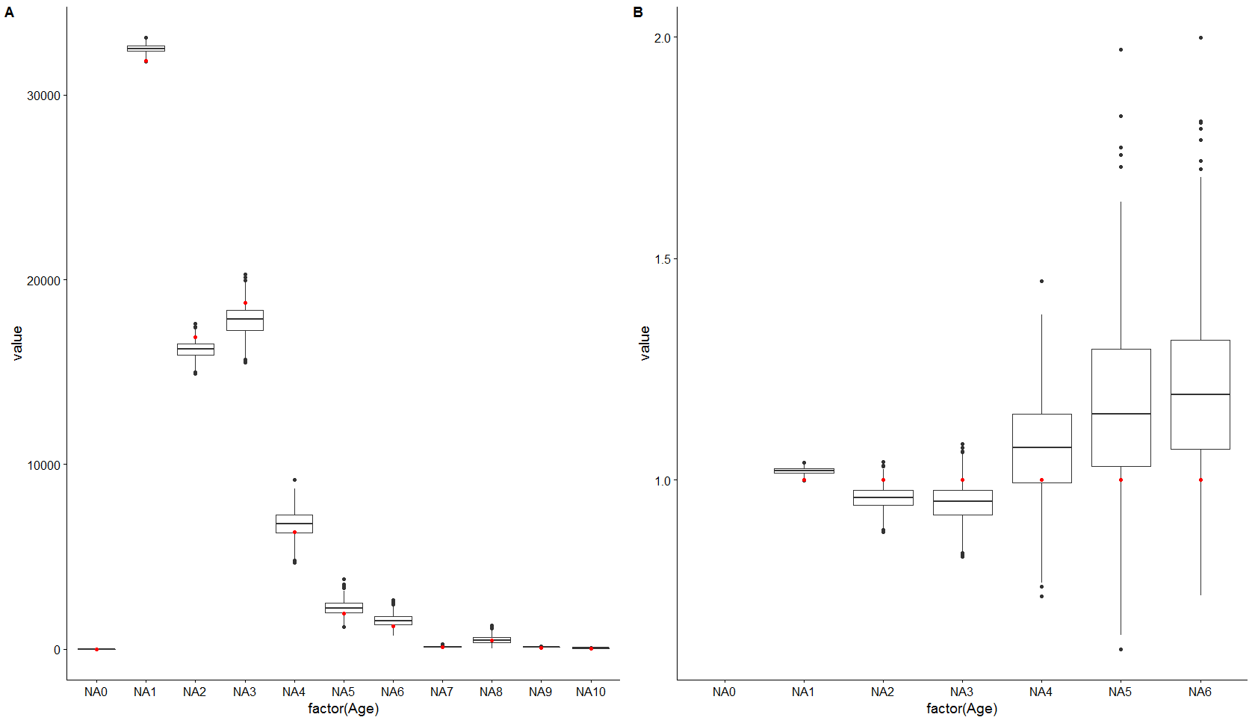

2010: Q1 Whiting, otolith selection using the base method, current situation. Left absolute numbers at age and right numbers at age divided by the original population. Red dots original population.

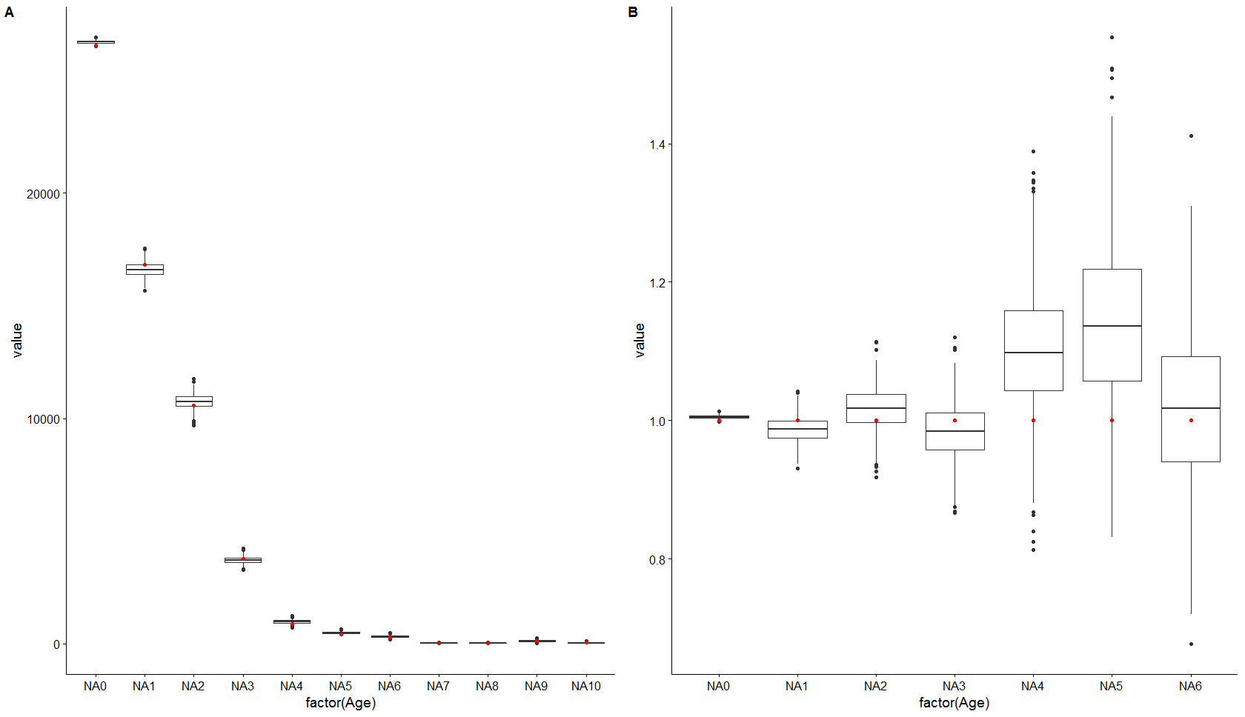

2010: Q3 Whiting, otolith selection using the base method, current situation. Left absolute numbers at age and right numbers at age divided by the original population. Red dots original population.

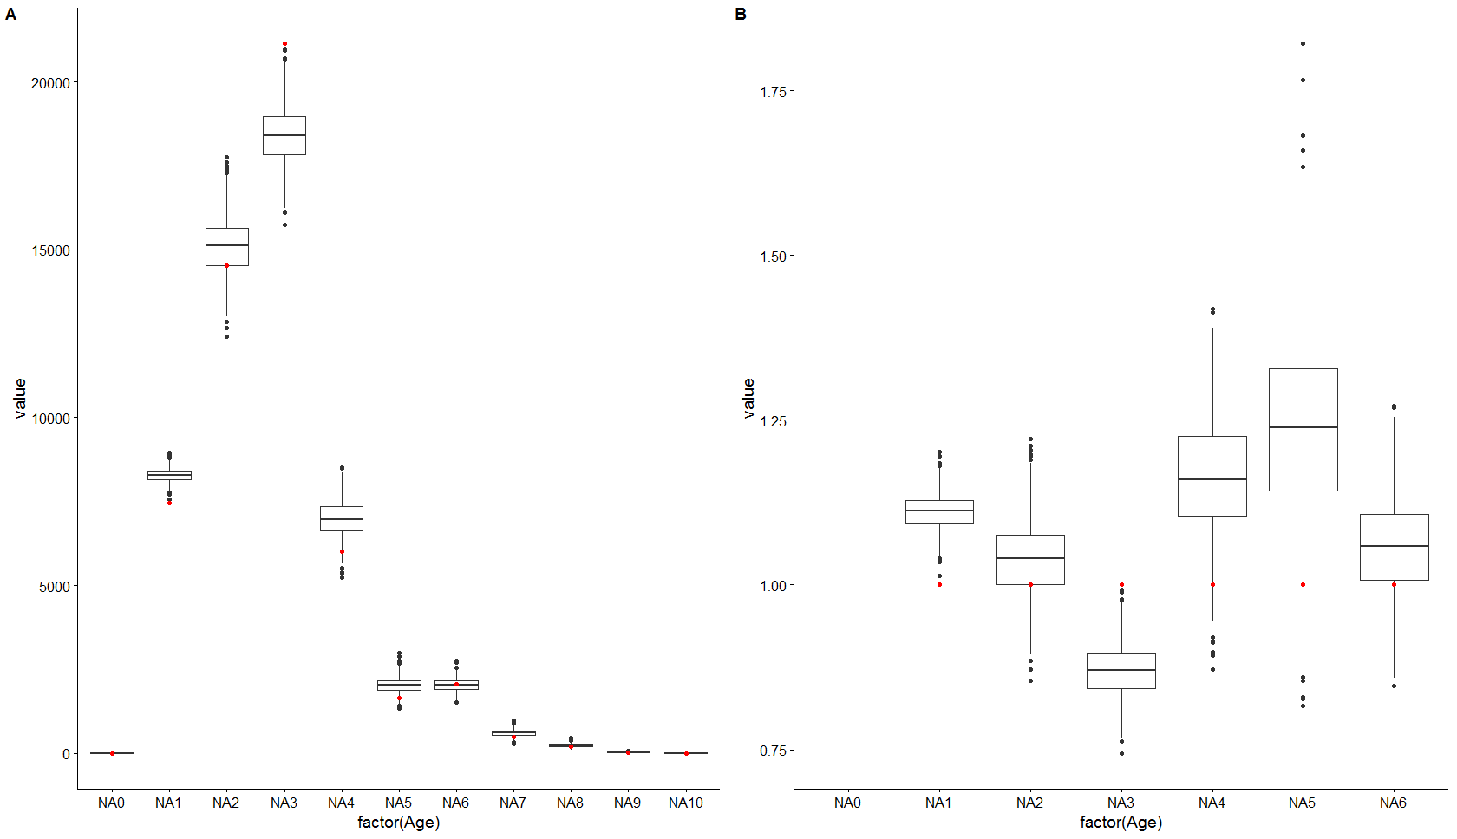

2013: Q1 Whiting, otolith selection using the base method, current situation. Left absolute numbers at age and right numbers at age divided by the original population. Red dots original population.

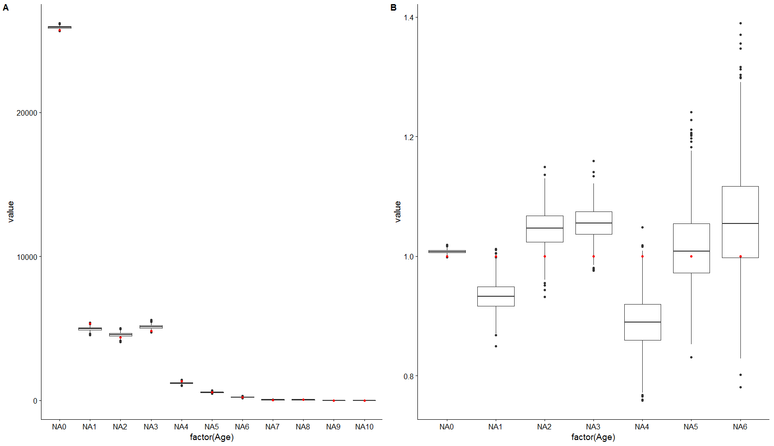

2013: Q3 Whiting, otolith selection using the base method, current situation. Left absolute numbers at age and right numbers at age divided by the original population. Red dots original population.

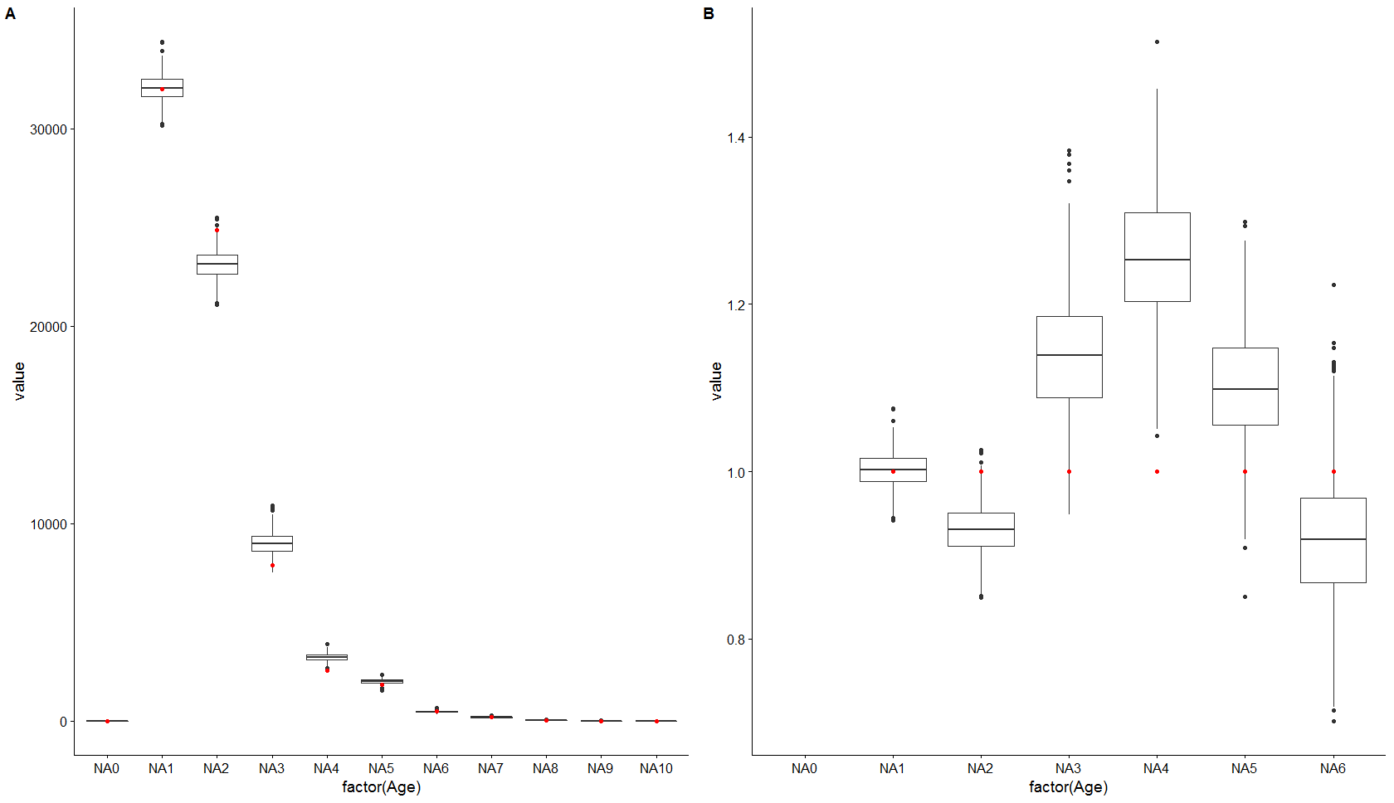

2015: Q1 Whiting, otolith selection using the base method, current situation. Left absolute numbers at age and right numbers at age divided by the original population. Red dots original population.

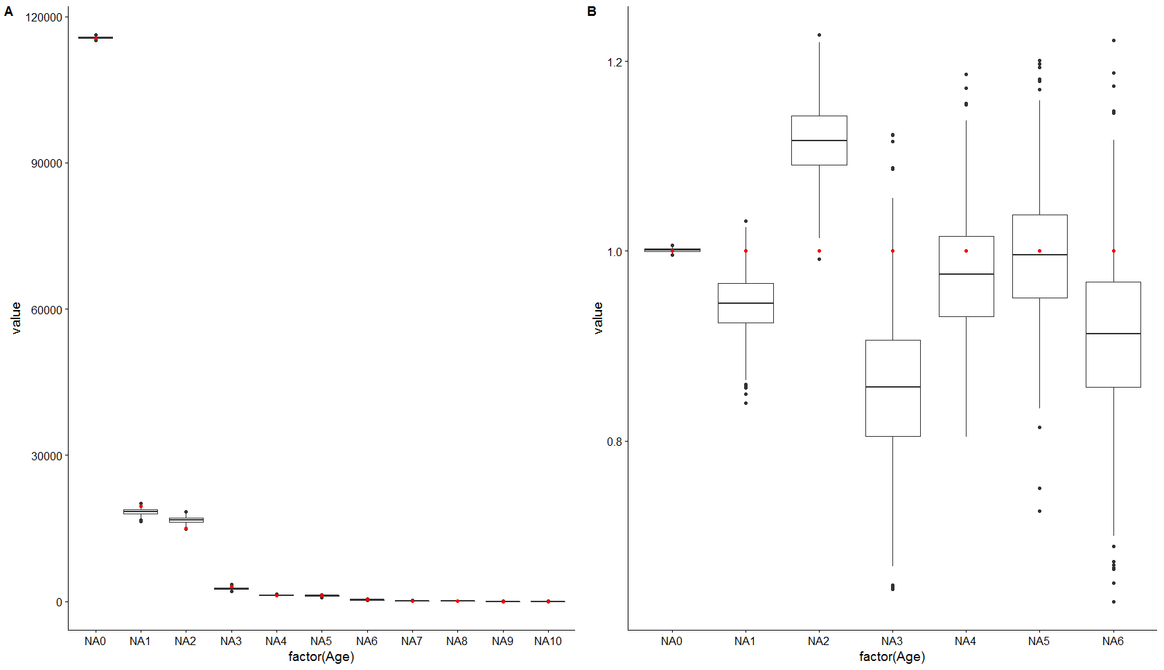

2015: Q3 Whiting, otolith selection using the base method, current situation. Left absolute numbers at age and right numbers at age divided by the original population. Red dots original population.

Method 1 current ALK

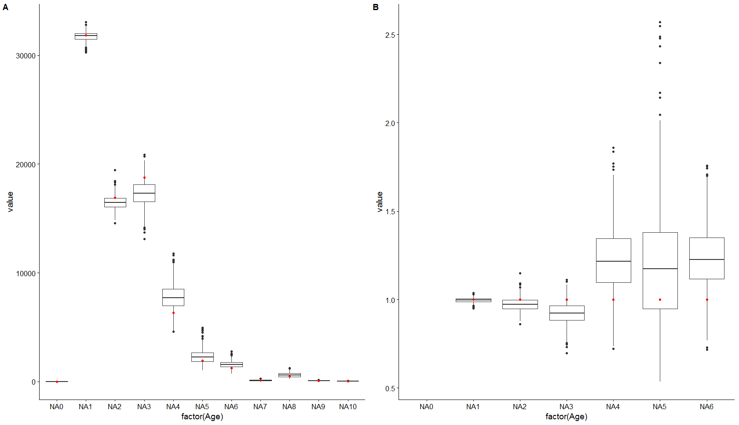

2010: Q1 Whiting, otolith selection using method 1 current method of creating the ALK. Left absolute numbers at age and right numbers at age divided by the original population. Red dots original population. 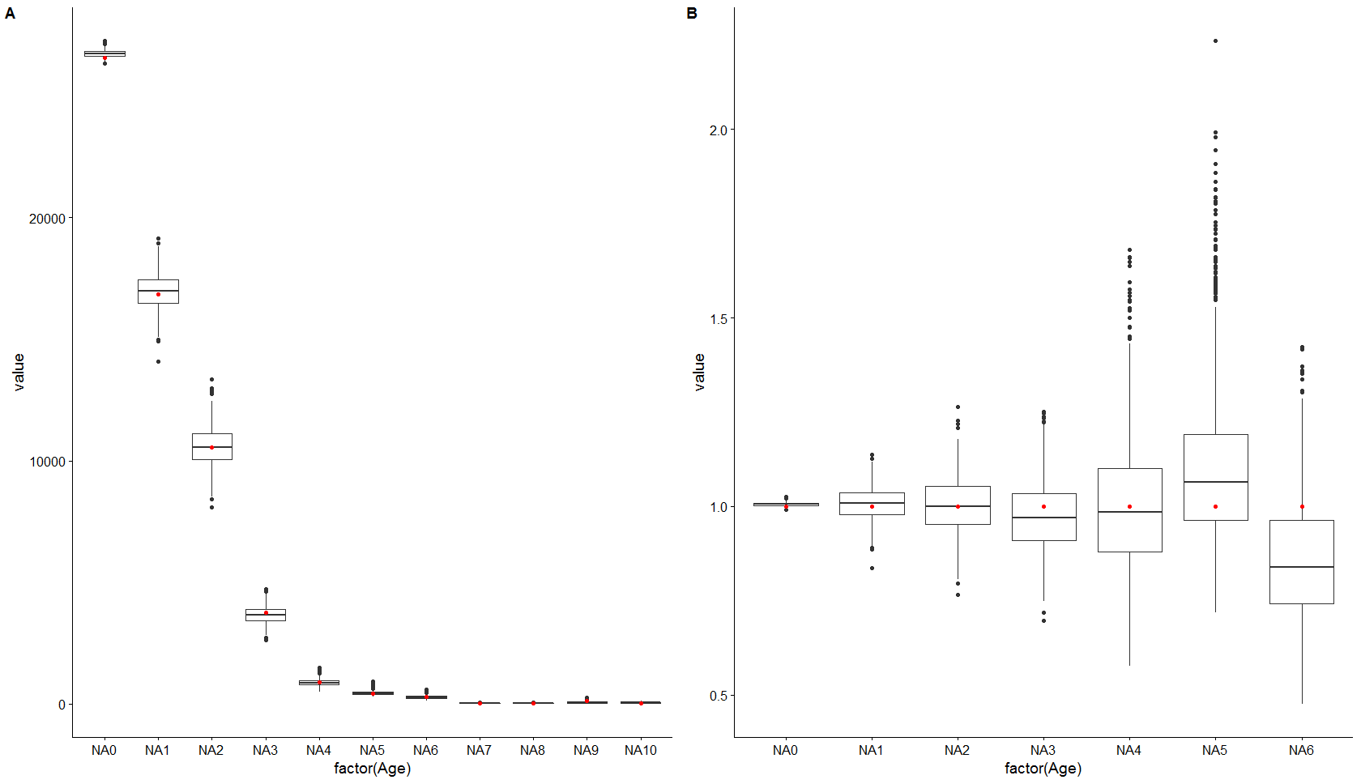

2010: Q3 Whiting, otolith selection using method 1 current method of creating the ALK. Left absolute numbers at age and right numbers at age divided by the original population. Red dots original population.

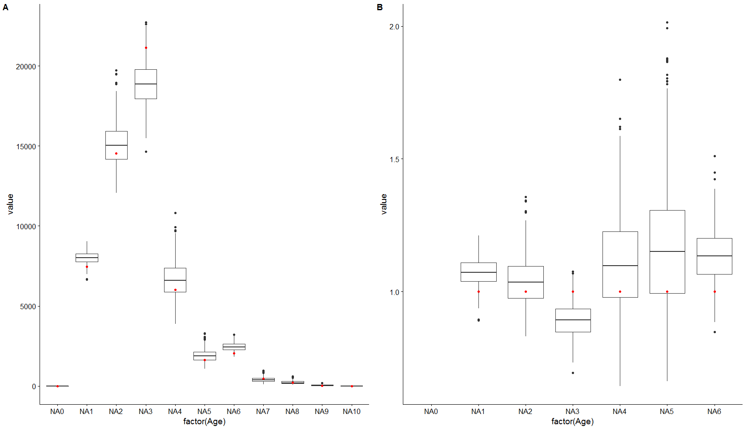

2013: Q1 Whiting, otolith selection using method 1 current method of creating the ALK. Left absolute numbers at age and right numbers at age divided by the original population. Red dots original population. 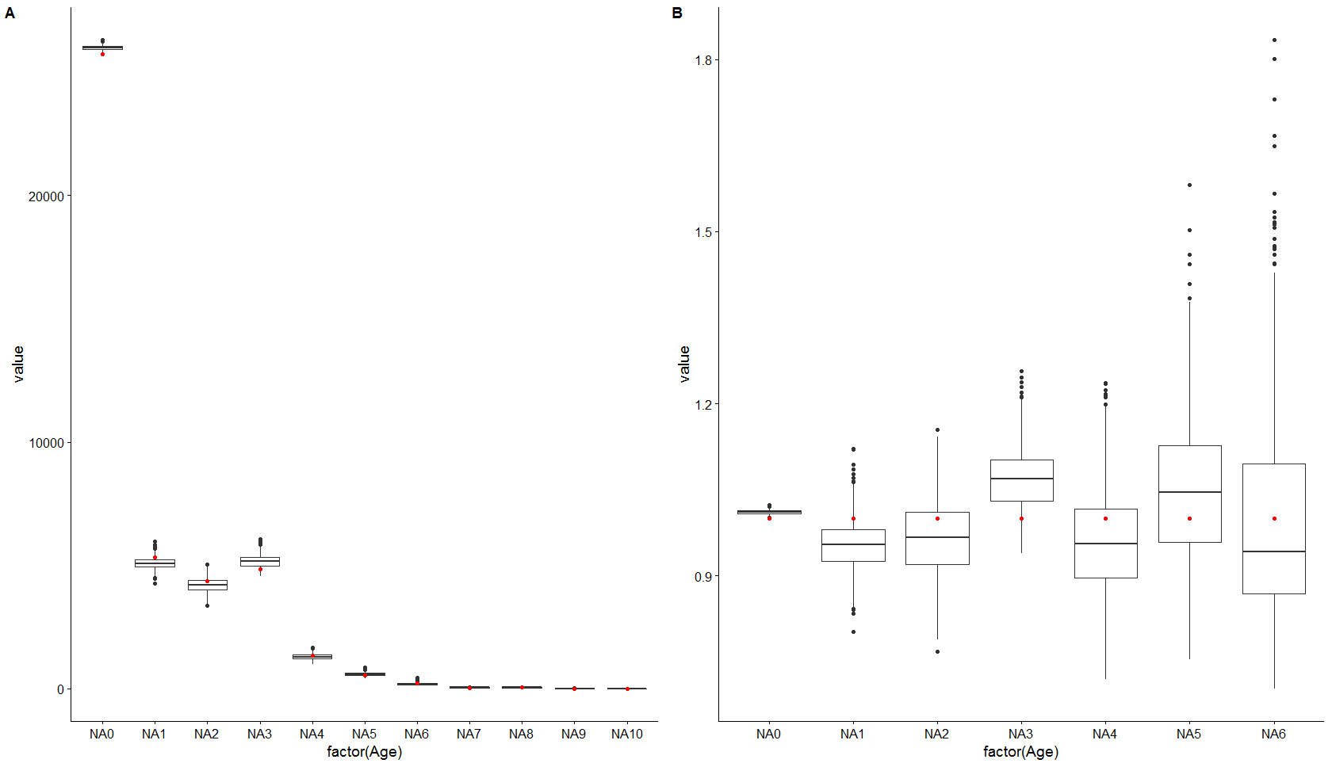

2013: Q3 Whiting, otolith selection using method 1 current method of creating the ALK. Left absolute numbers at age and right numbers at age divided by the original population. Red dots original population.

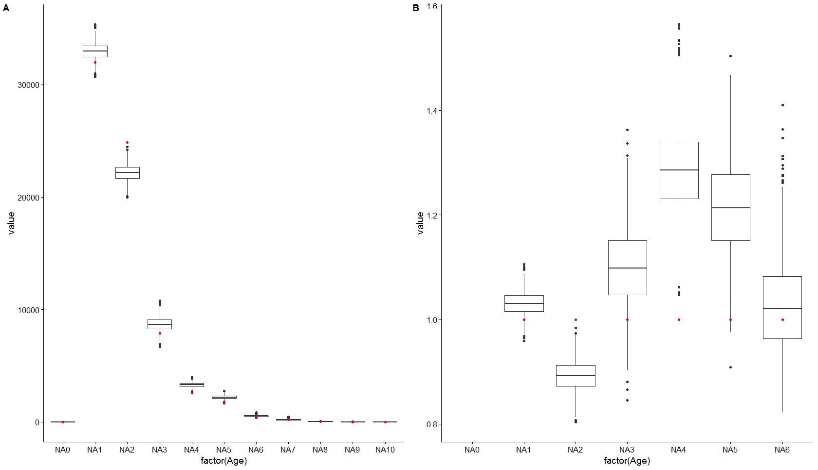 2015: Q1 Whiting, otolith selection using method 1 current method of creating the ALK. Left absolute numbers at age and right numbers at age divided by the original population. Red dots original population.

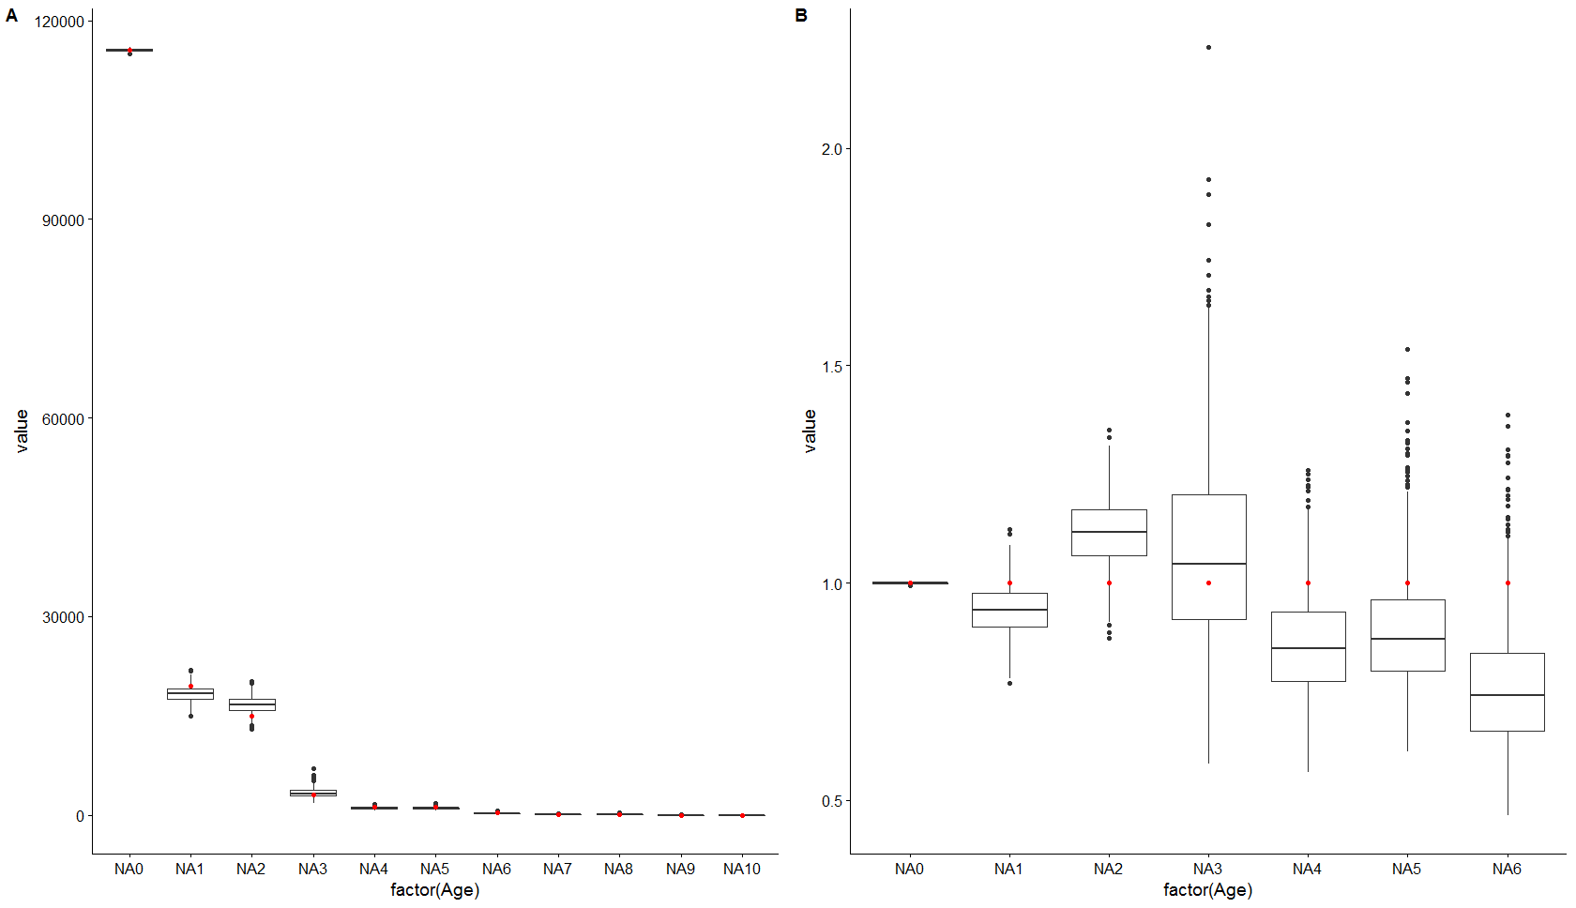

2015: Q3 Whiting, otolith selection using method 1 current method of creating the ALK. Left absolute numbers at age and right numbers at age divided by the original population. Red dots original population.

Method 1 Modelled ALK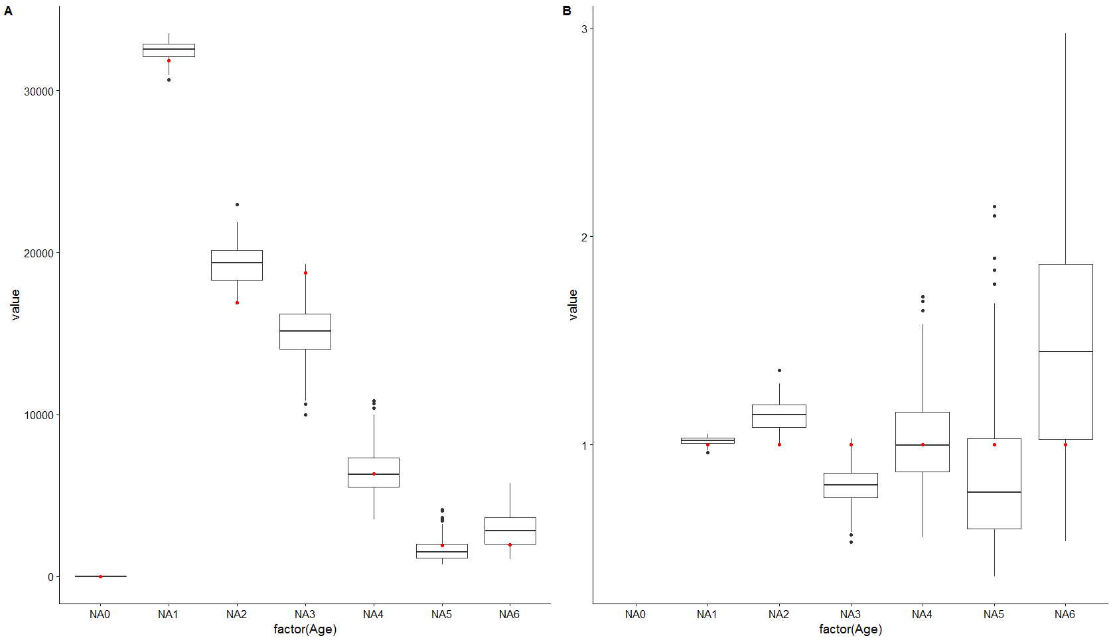

2010: Q1 Whiting, otolith selection using method 1 modelling the ALK by haul. Left absolute numbers at age and right numbers at age divided by the original population. Red dots original population.

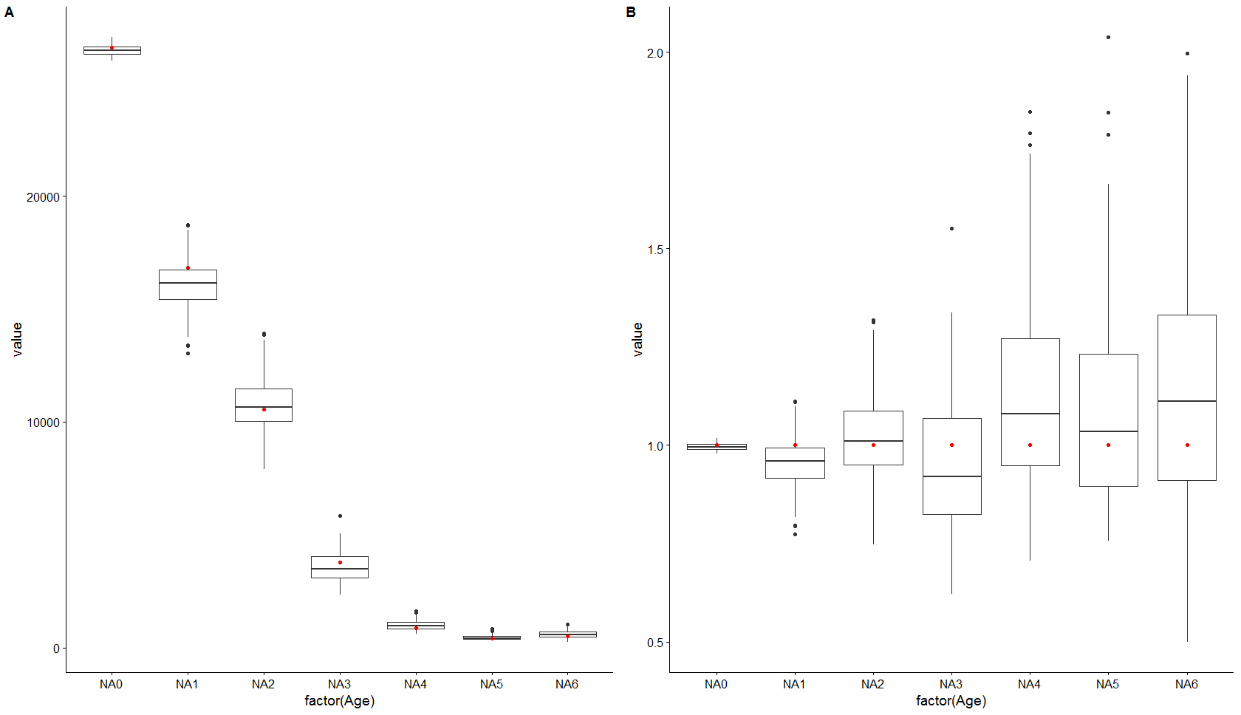

2010: Q3 Whiting, otolith selection using method 1 modelling the ALK by haul. Left absolute numbers at age and right numbers at age divided by the original population. Red dots original population.

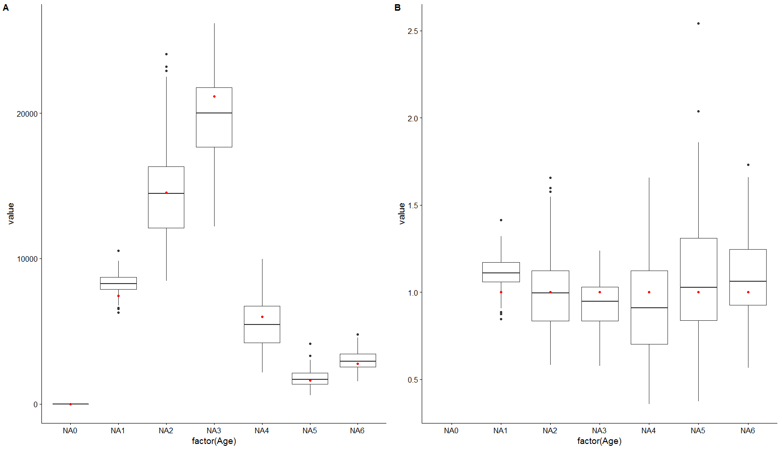

2013: Q1 Whiting, otolith selection using method 1 modelling the ALK by haul. Left absolute numbers at age and right numbers at age divided by the original population. Red dots original population.

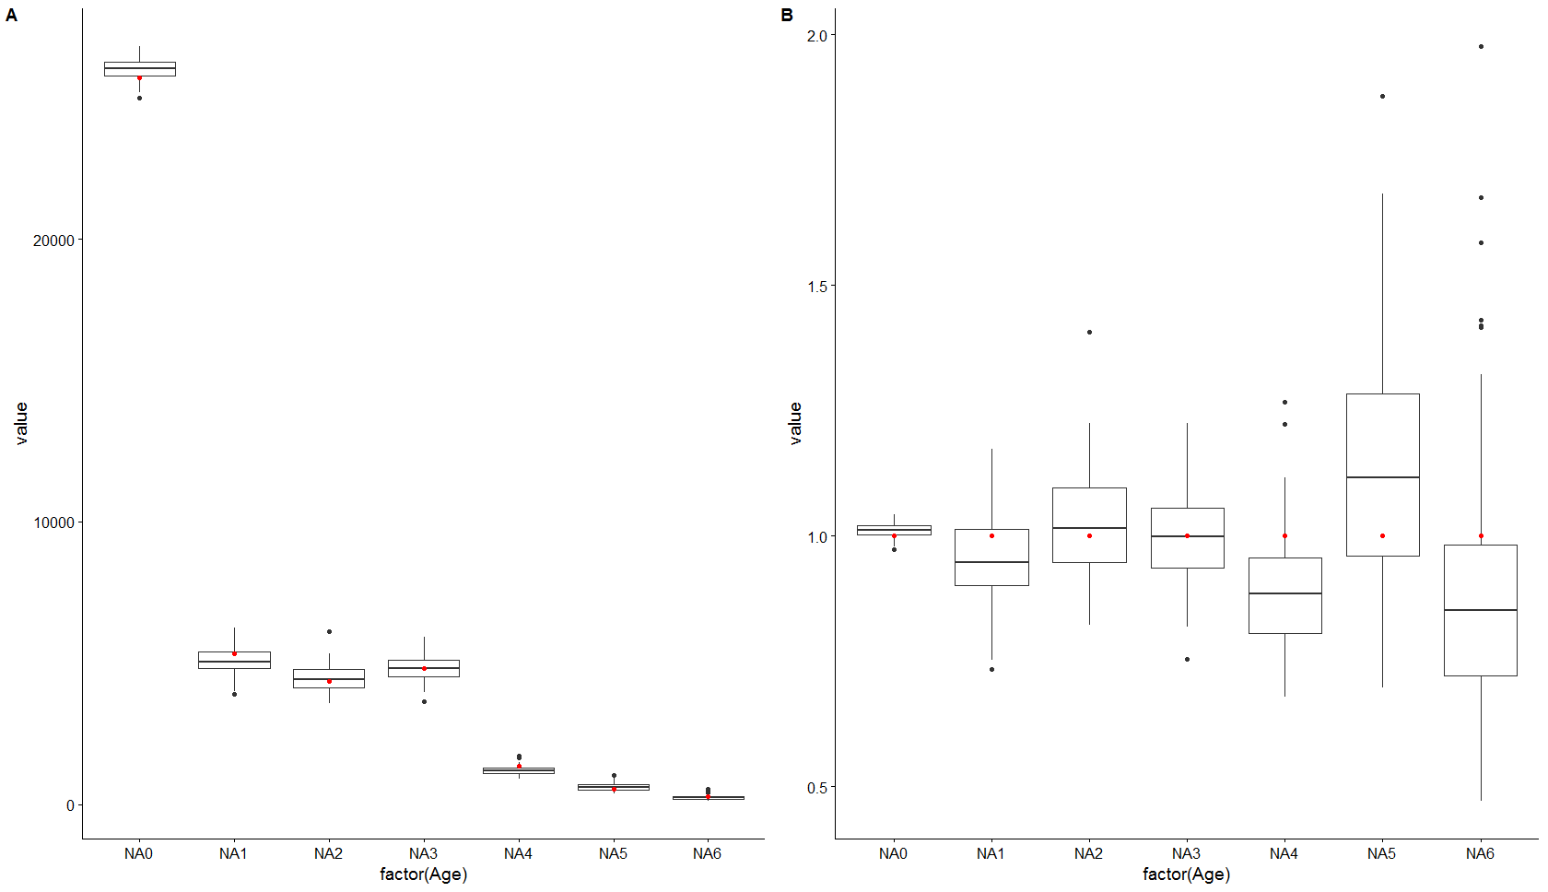

2013: Q3 Whiting, otolith selection using method 1 modelling the ALK by haul. Left absolute numbers at age and right numbers at age divided by the original population. Red dots original population.

2015

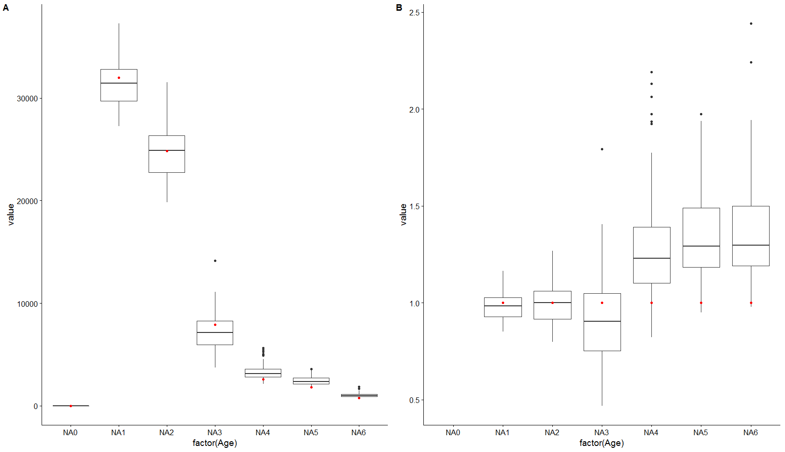

2015: Q1 Whiting, otolith selection using method 1 modelling the ALK by haul. Left absolute numbers at age and right numbers at age divided by the original population. Red dots original population.

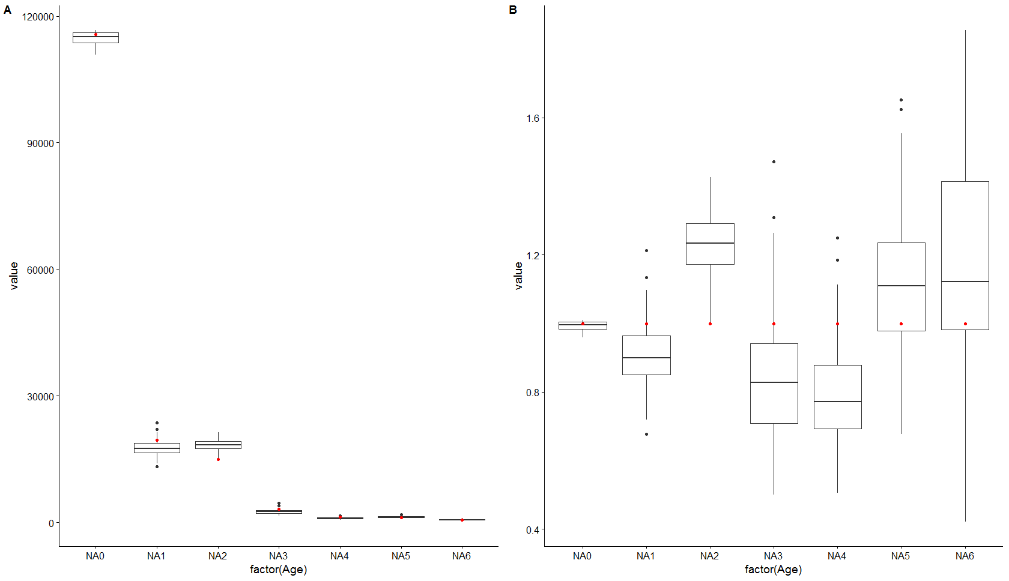

2015: Q3 Whiting, otolith selection using method 1 modelling the ALK by haul. Left absolute numbers at age and right numbers at age divided by the original population. Red dots original population.

Method 2 Modelled ALK

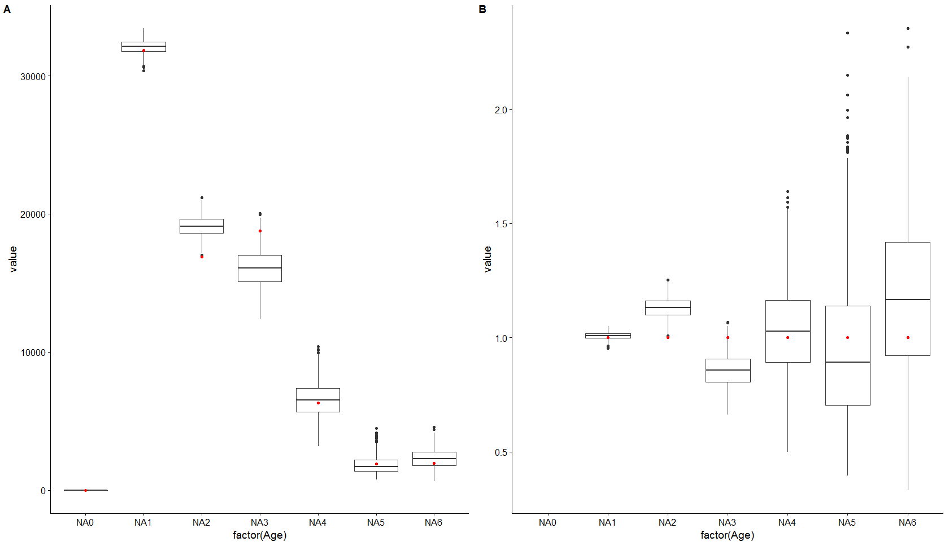

2010: Q1 Whiting, otolith selection using method 2 modelling the ALK by haul. Left absolute numbers at age and right numbers at age divided by the original population. Red dots original population.

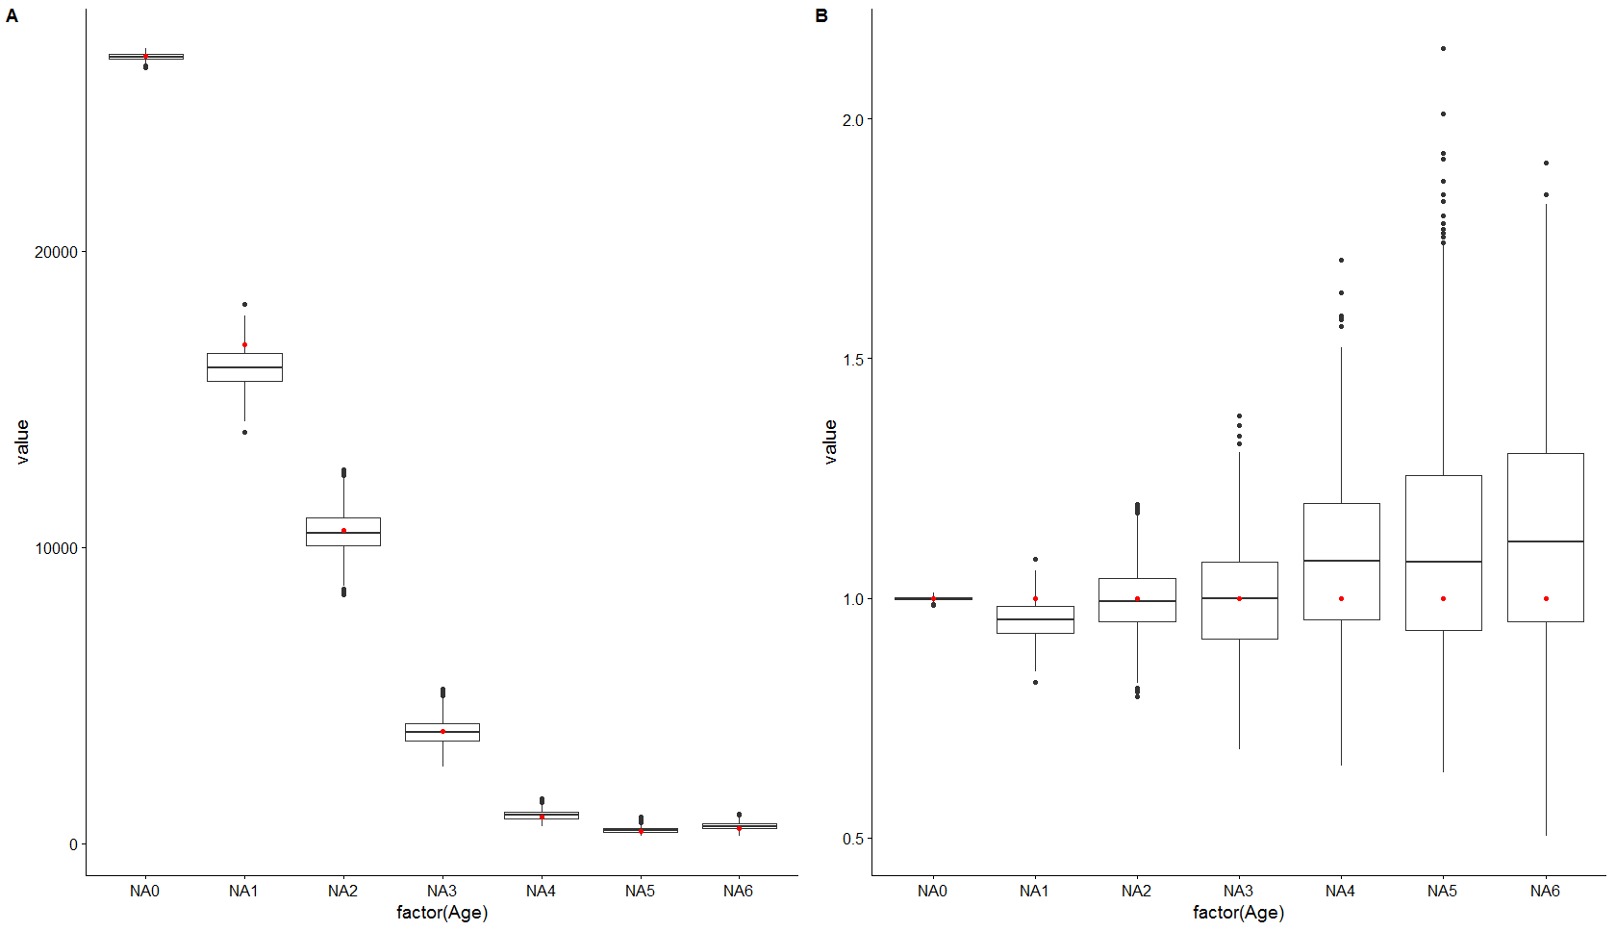

2010: Q3 Whiting, otolith selection using method 1 modelling the ALK by haul. Left absolute numbers at age and right numbers at age divided by the original population. Red dots original population.

**Herring**

Base 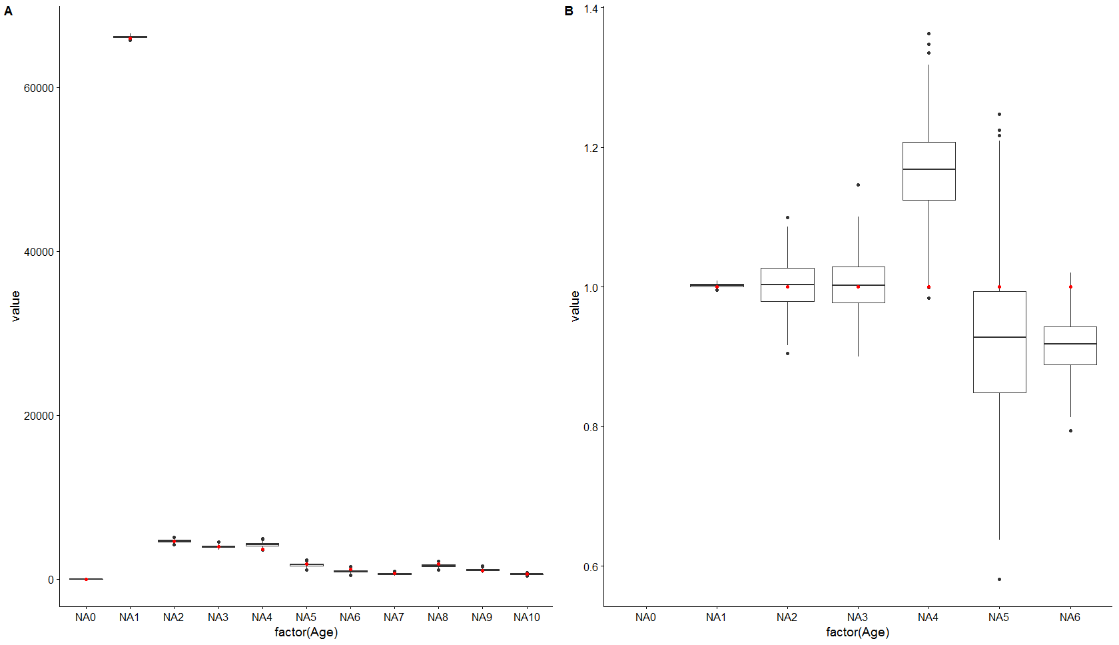

2010: Q1 Herring, otolith selection using the base method, current situation. A) absolute numbers at age and B) numbers at age divided by the original population. Red dots original population.

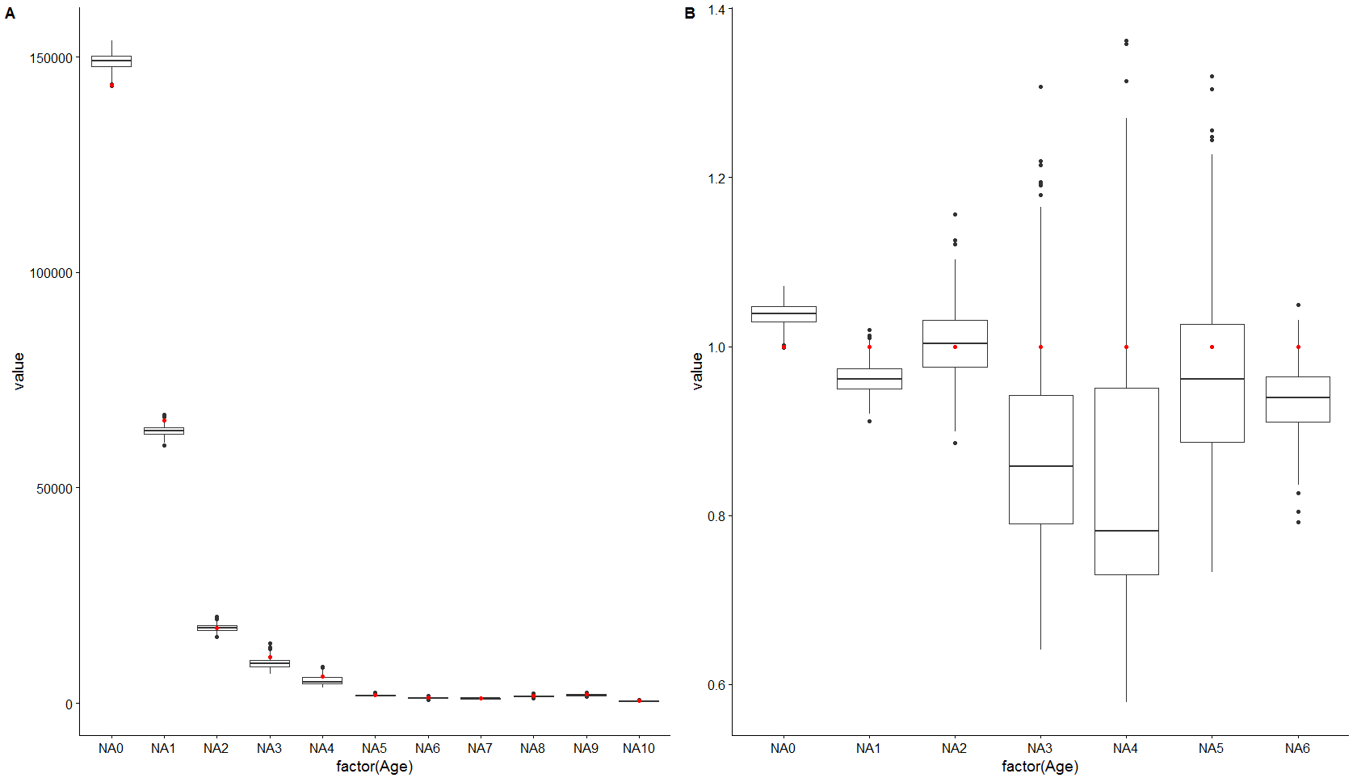

2010: Q3 Herring, otolith selection using the base method, current situation. A) absolute numbers at age and B) numbers at age divided by the original population. Red dots original population.

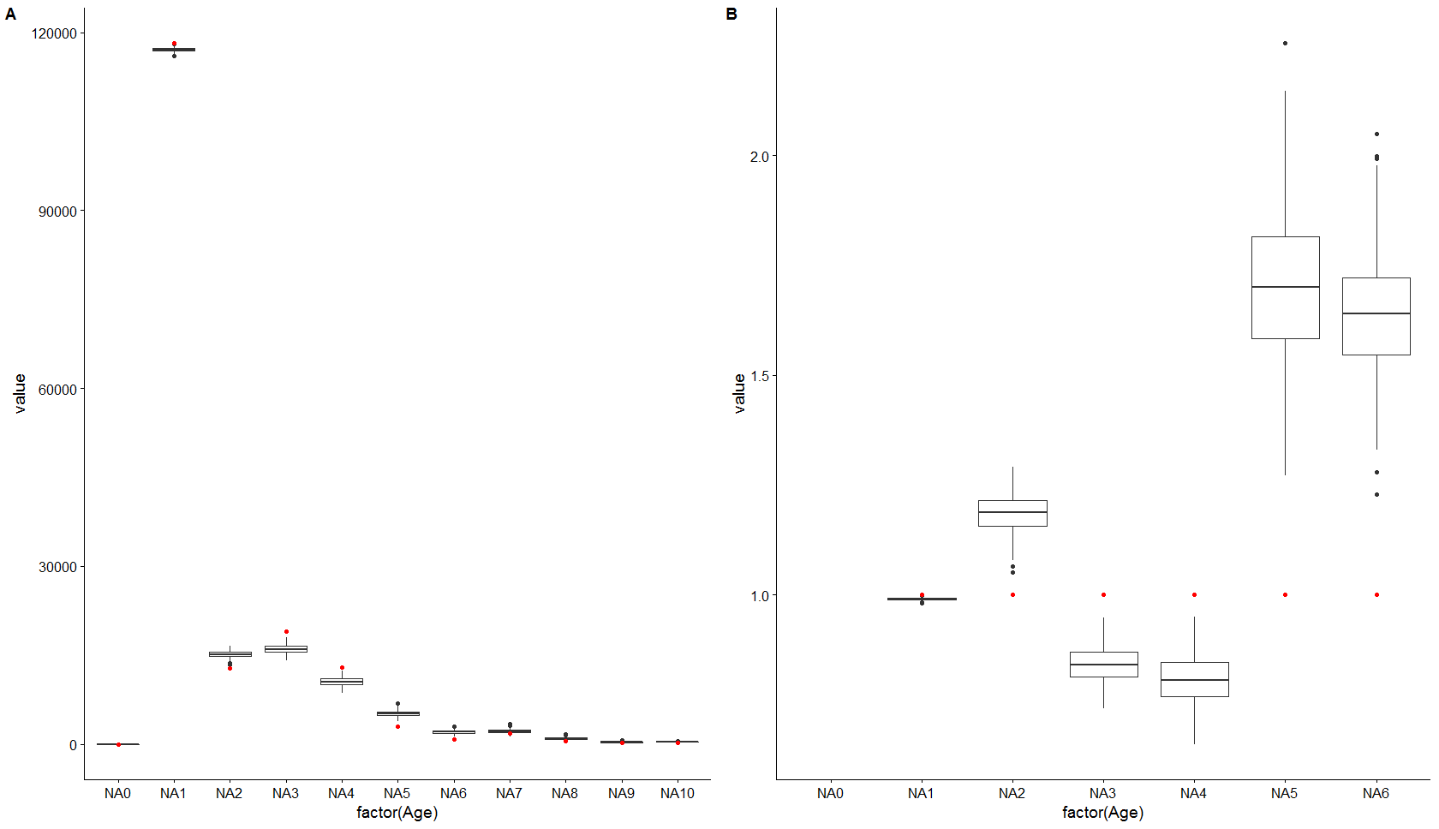

2013: Q1 Herring, otolith selection using the base method, current situation. A) absolute numbers at age and B) numbers at age divided by the original population. Red dots original population.

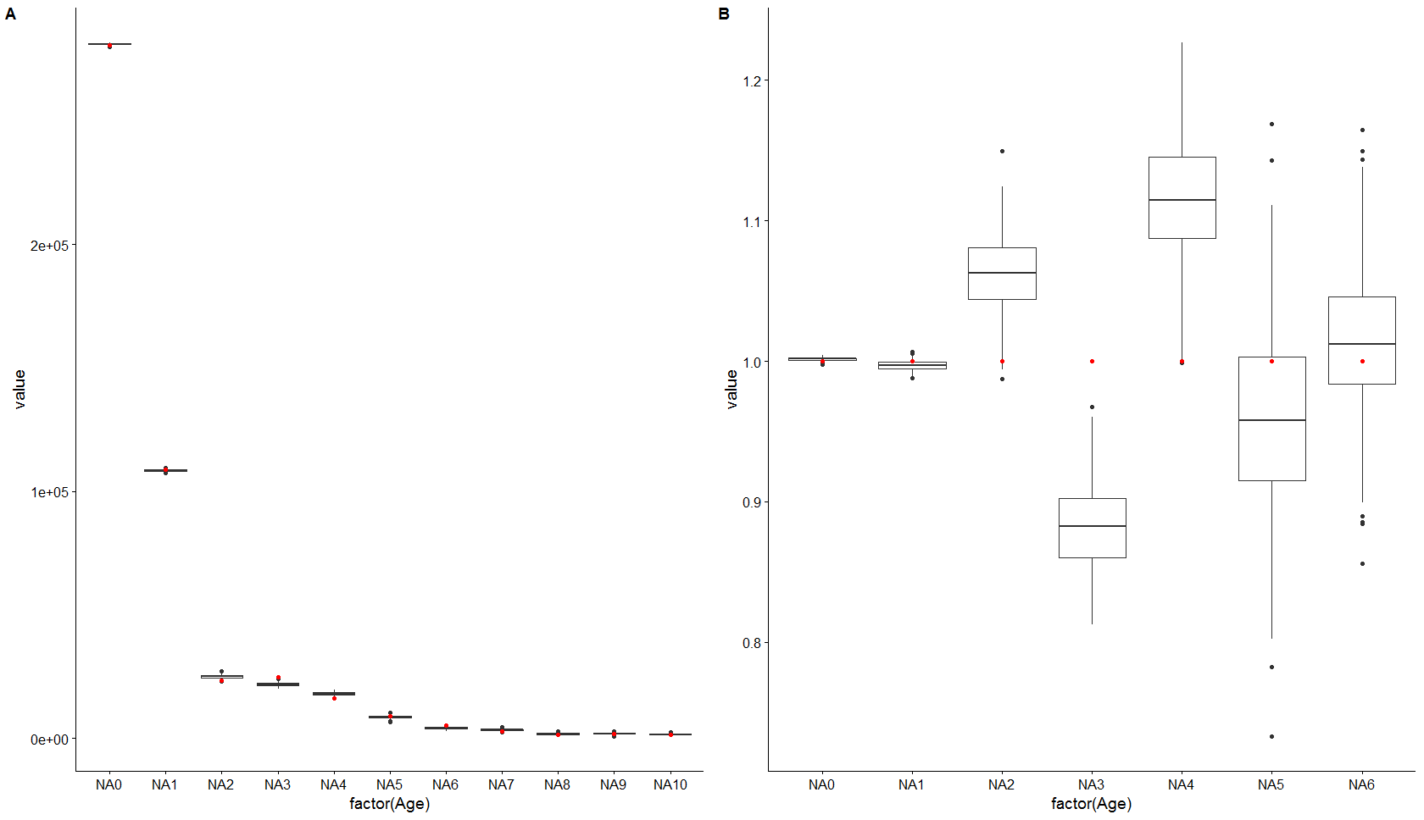 2013: Q3 Herring, otolith selection using the base method, current situation. A) absolute numbers at age and B) numbers at age divided by the original population. Red dots original population.

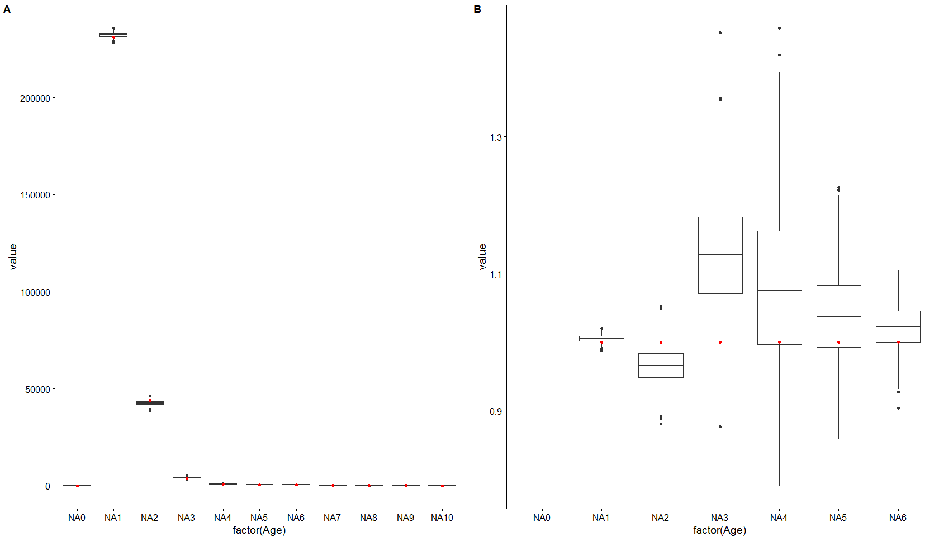 2015: Q1 Herring, otolith selection using the base method, current situation. A) absolute numbers at age and B) numbers at age divided by the original population. Red dots original population.

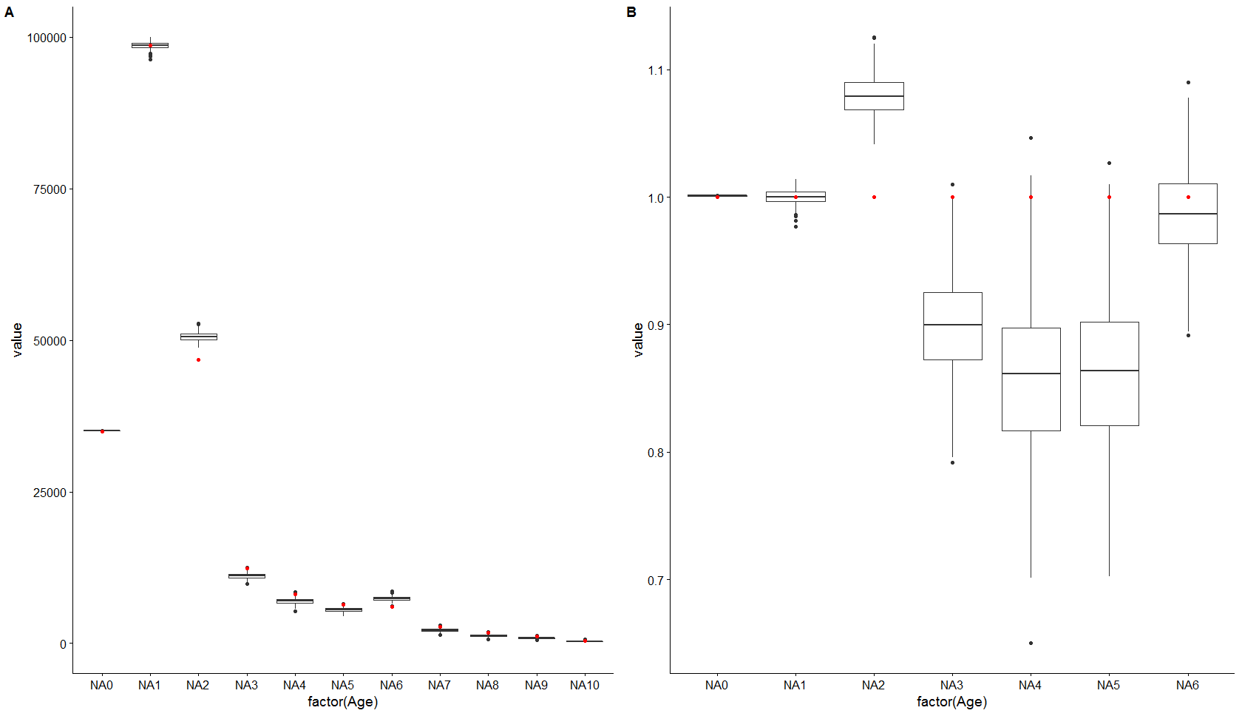

2015: Q3 Herring, otolith selection using the base method, current situation. A) absolute numbers at age and B) numbers at age divided by the original population. Red dots original population.

Model 1 current ALK

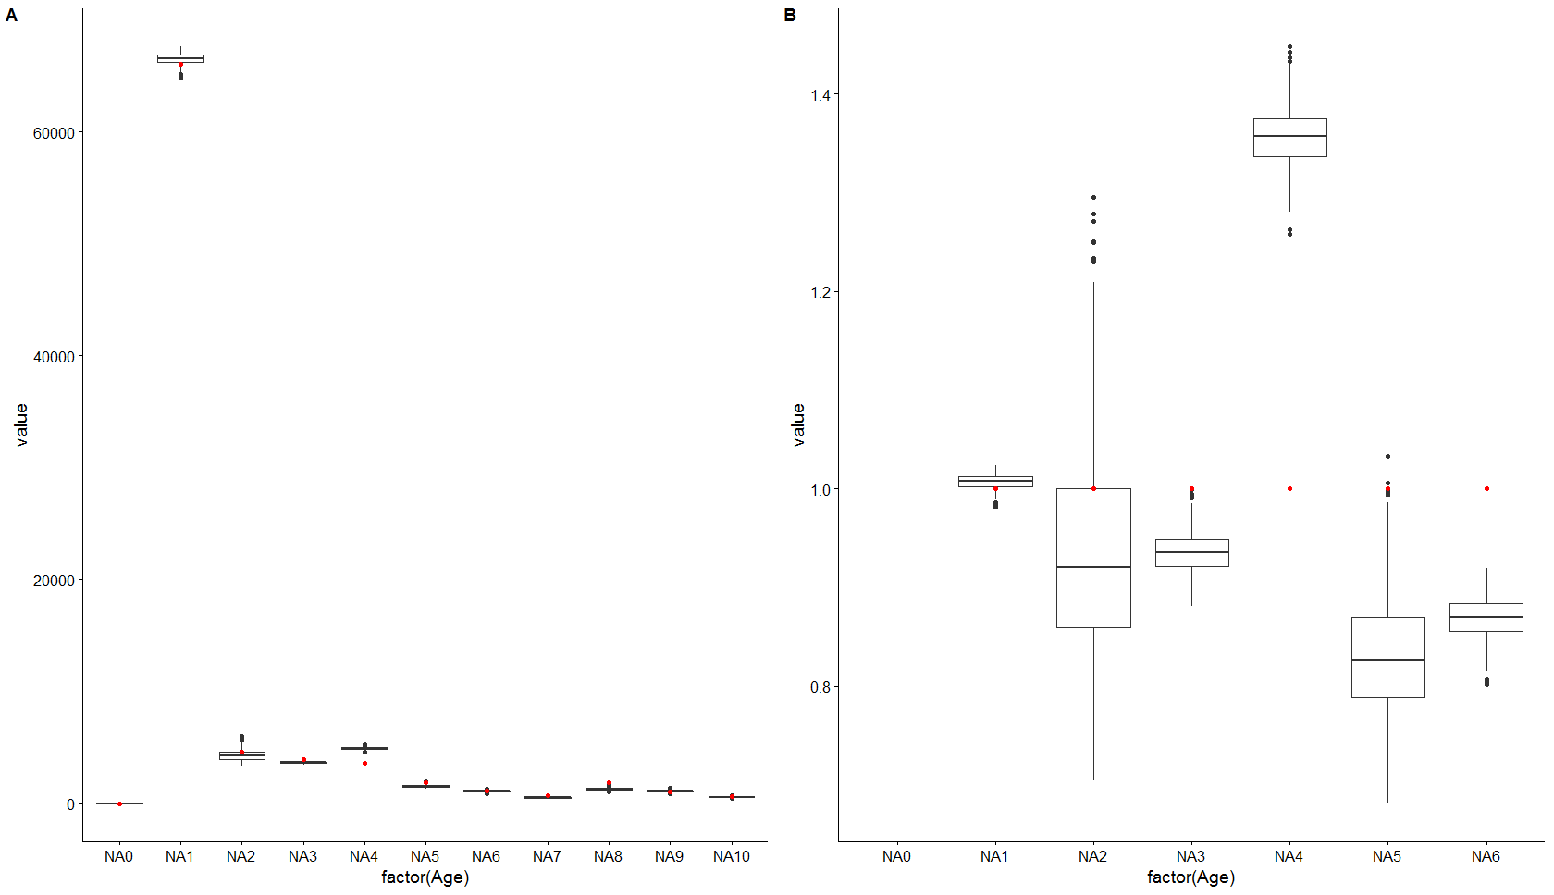

2010: Q1 herring, otolith selection using method 1 current method of creating the ALK. A) absolute numbers at age and B) numbers at age divided by the original population. Red dots original population.

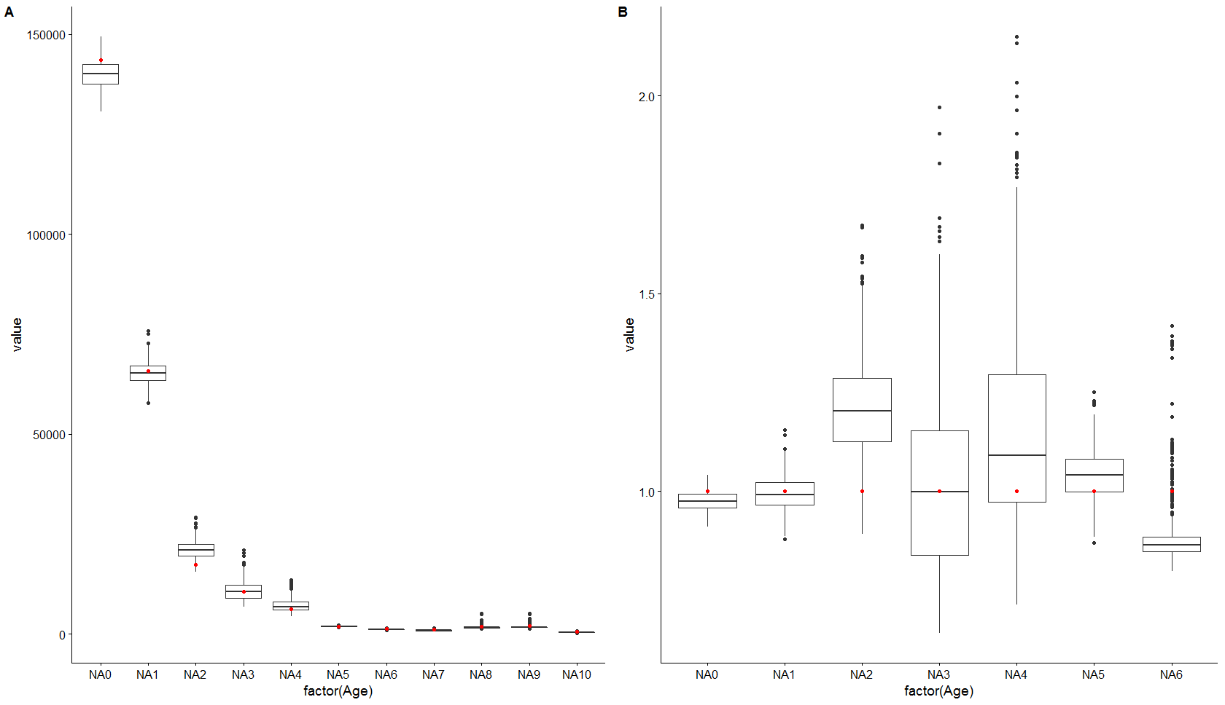

2010: Q1 herring, otolith selection using method 1 current method of creating the ALK. A) absolute numbers at age and B) numbers at age divided by the original population. Red dots original population.

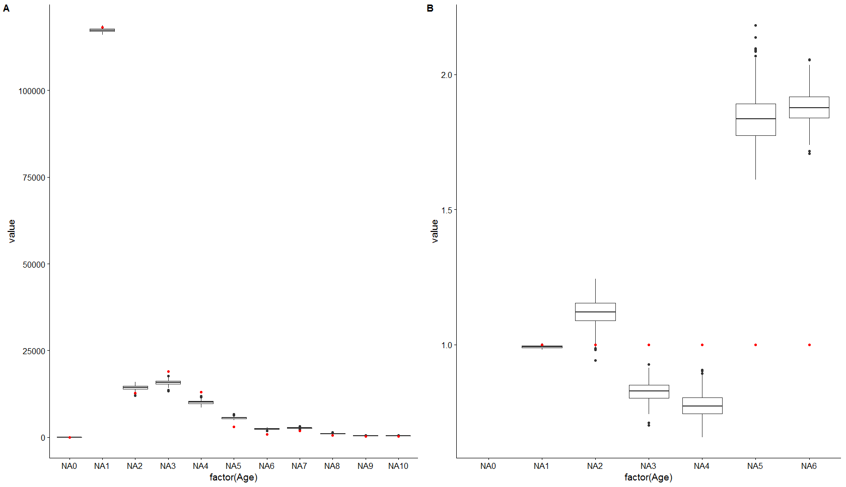

2013: Q1 herring, otolith selection using method 1 current method of creating the ALK. A) absolute numbers at age and B) numbers at age divided by the original population. Red dots original population.

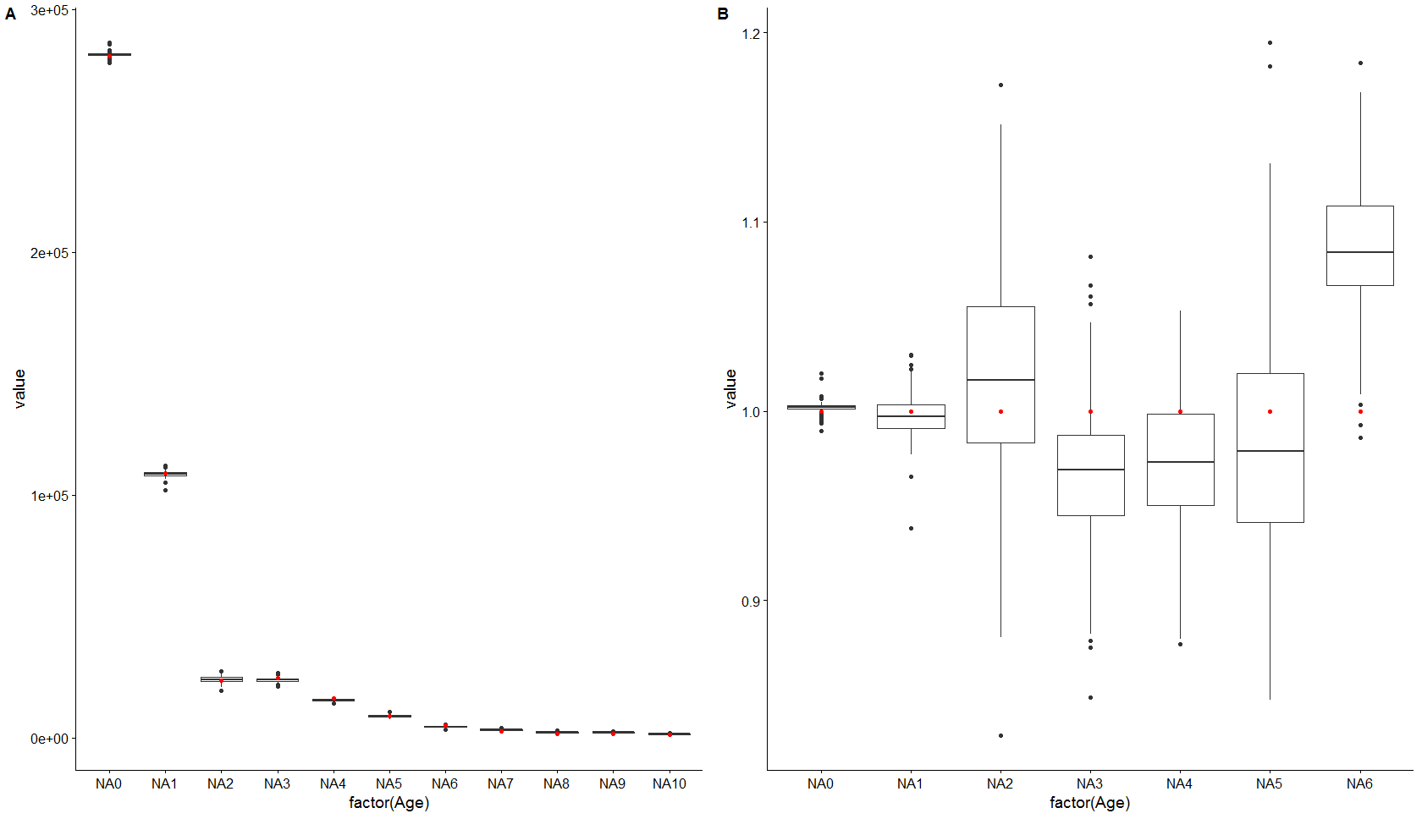

2013: Q3 herring, otolith selection using method 1 current method of creating the ALK. A) absolute numbers at age and B) numbers at age divided by the original population. Red dots original population.

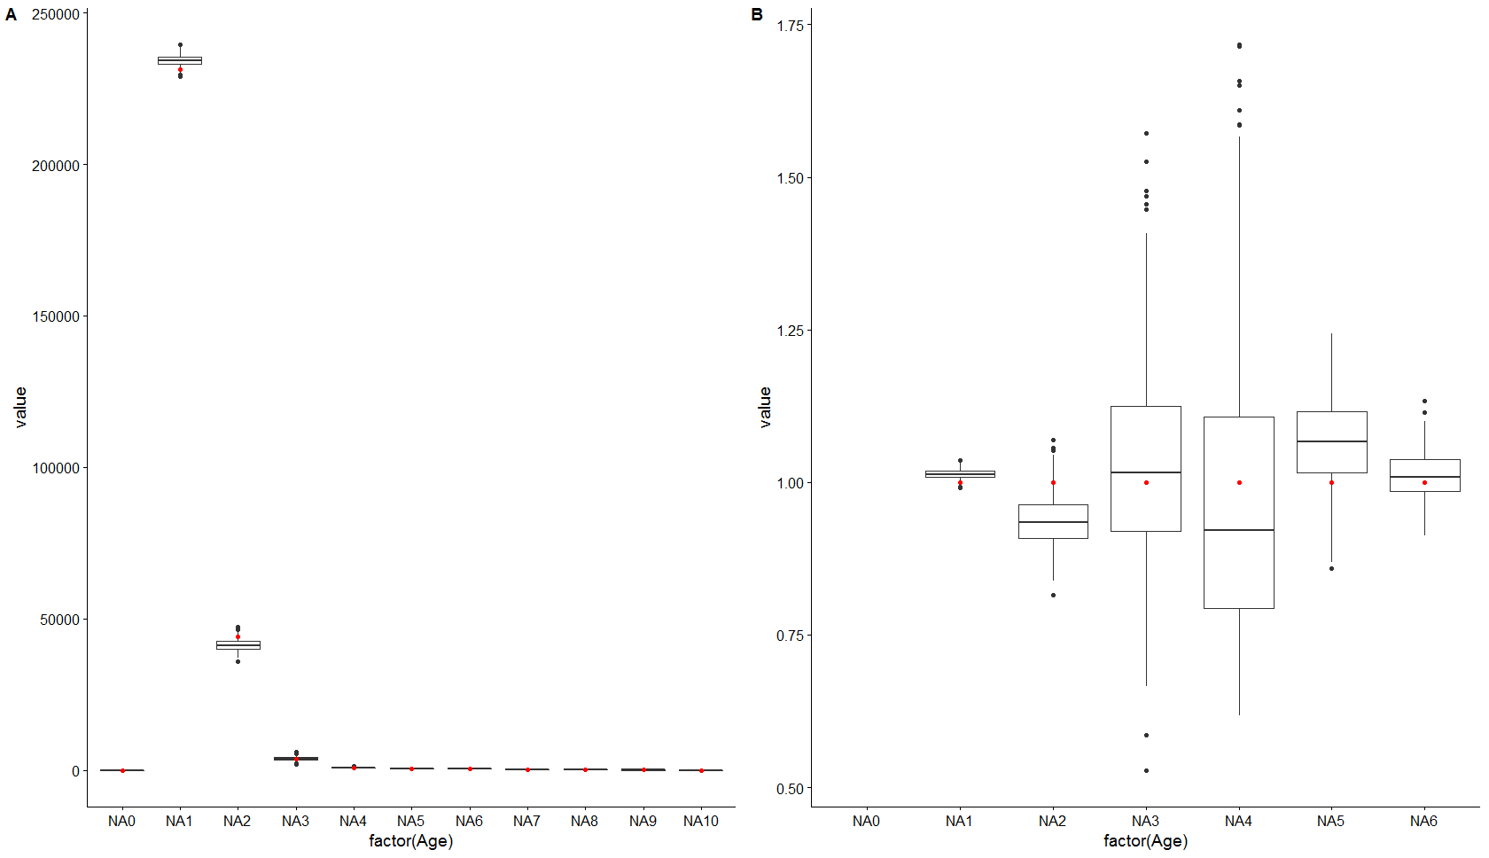

2015: Q1 herring, otolith selection using method 1 current method of creating the ALK. A) absolute numbers at age and B) numbers at age divided by the original population. Red dots original population.

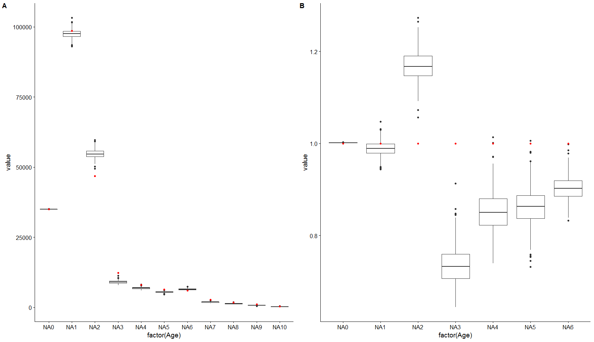

2015: Q3 herring, otolith selection using method 1 current method of creating the ALK. A) absolute numbers at age and B) numbers at age divided by the original population. Red dots original population.

Model 1 modelled ALK

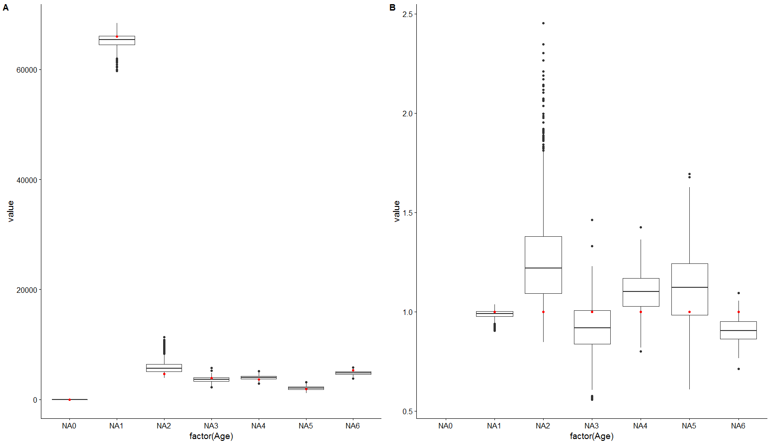

2010: Q1 herring, otolith selection using method 1 modelling the ALK by haul. Left absolute numbers at age and right numbers at age divided by the original population. Red dots original population.

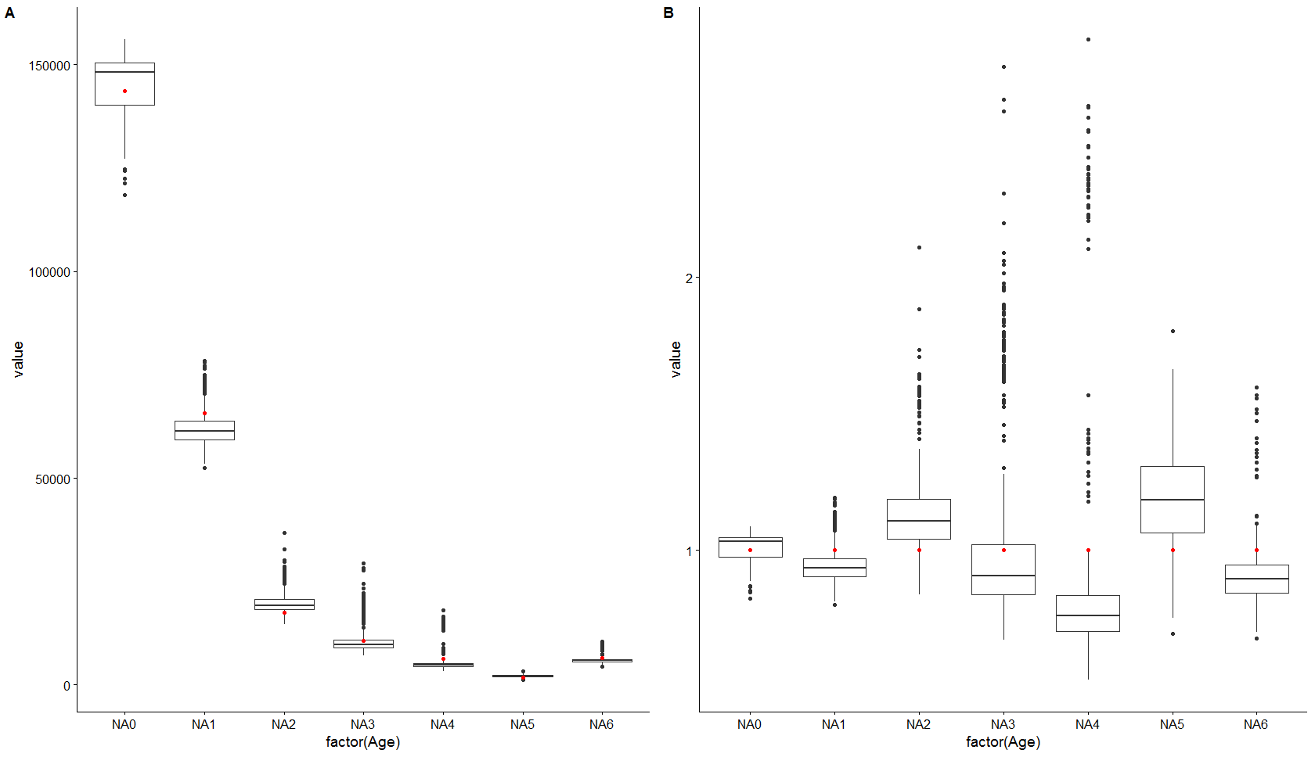

2010: Q3 herring, otolith selection using method 1 modelling the ALK by haul. Left absolute numbers at age and right numbers at age divided by the original population. Red dots original population.

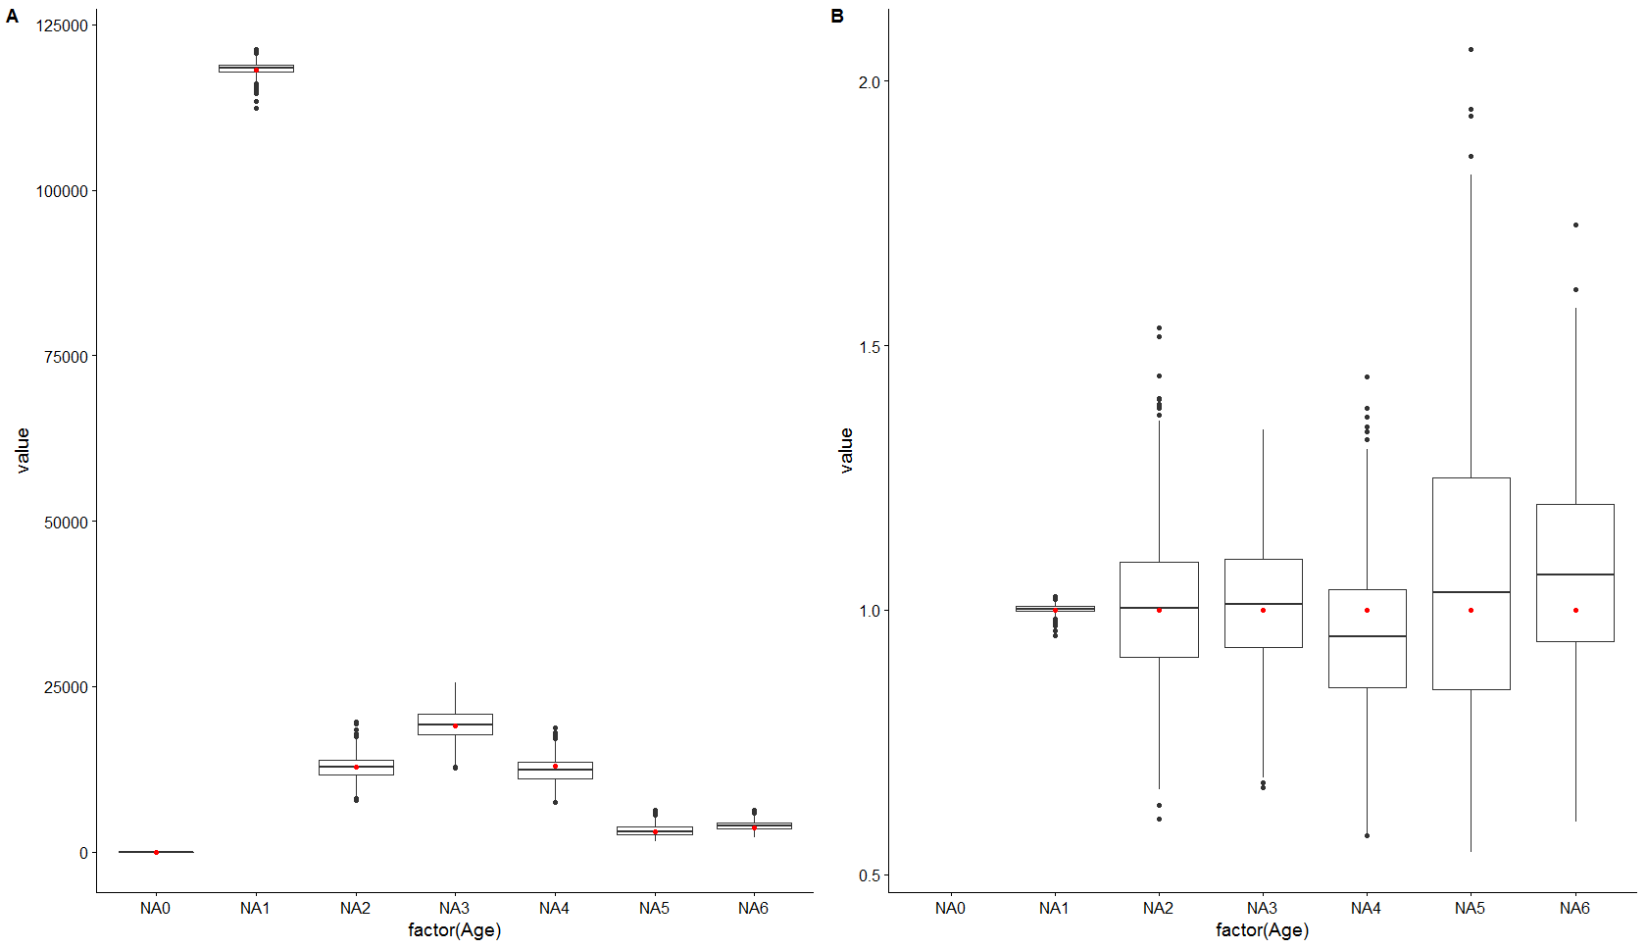

2013: Q1 herring, otolith selection using method 1 modelling the ALK by haul. Left absolute numbers at age and right numbers at age divided by the original population. Red dots original population.

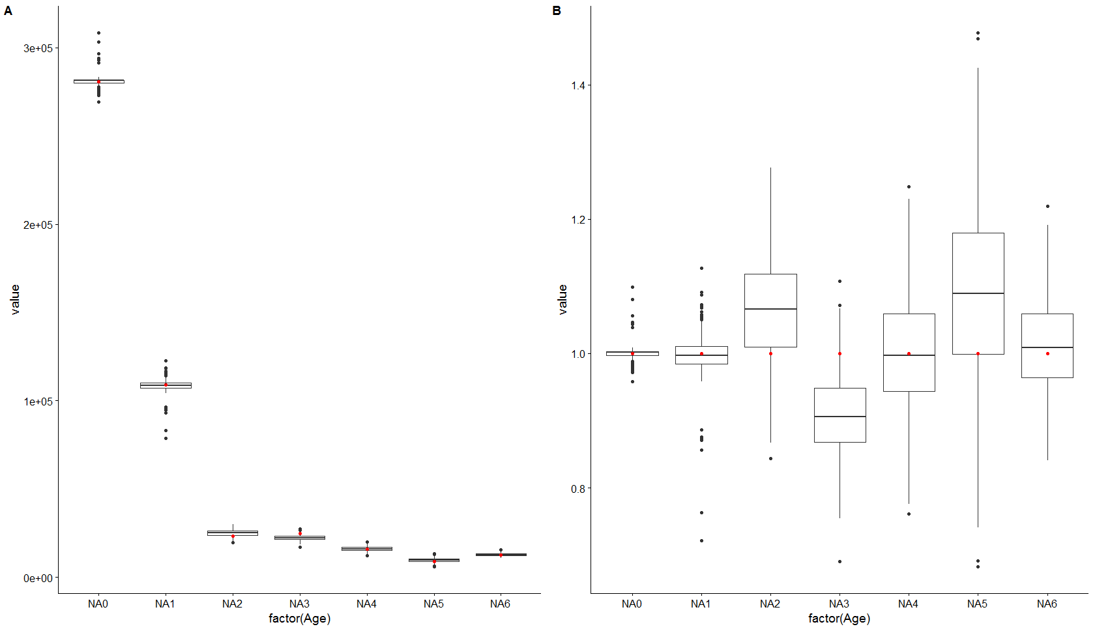

2013: Q3 herring, otolith selection using method 1 modelling the ALK by haul. Left absolute numbers at age and right numbers at age divided by the original population. Red dots original population.

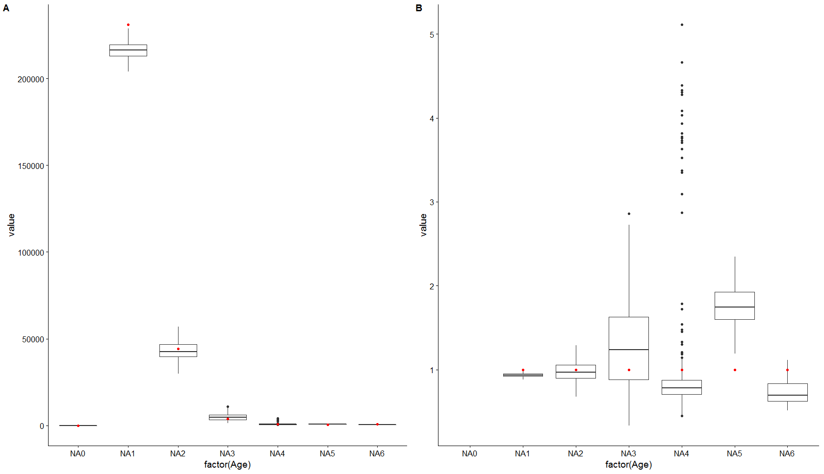

2015: Q1 herring, otolith selection using method 1 modelling the ALK by haul. Left absolute numbers at age and right numbers at age divided by the original population. Red dots original population.

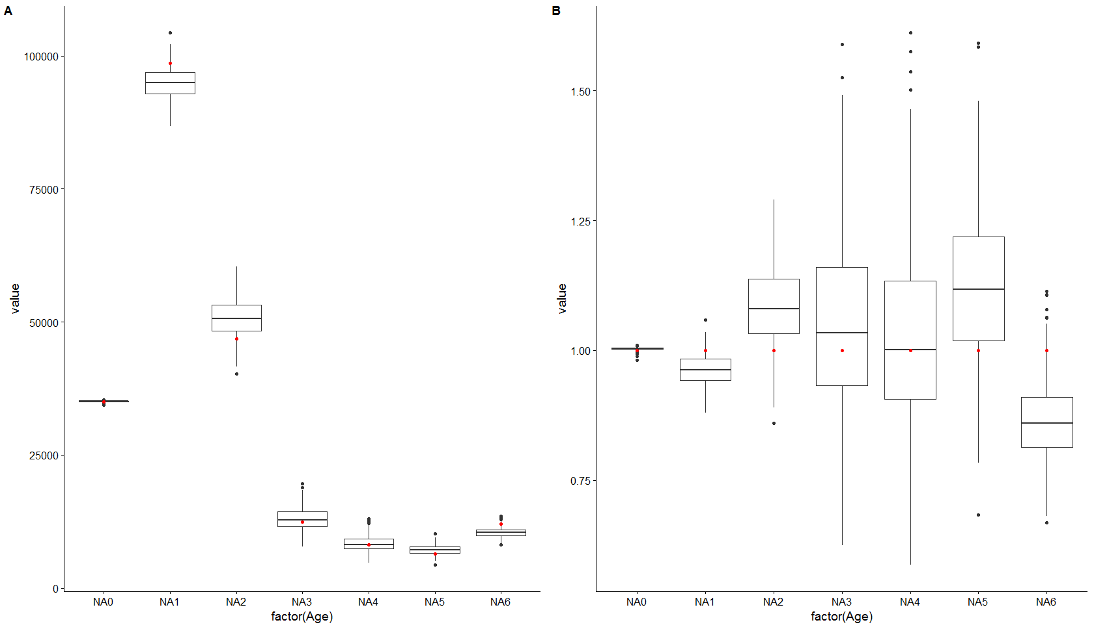

2015: Q3 herring, otolith selection using method 1 modelling the ALK by haul. Left absolute numbers at age and right numbers at age divided by the original population. Red dots original population.